Dual View X-ray Inspection System ZKX6550D

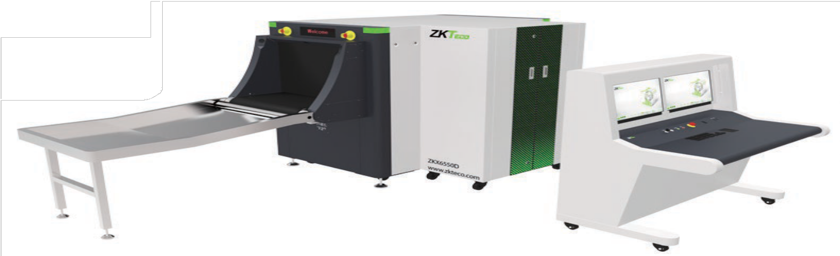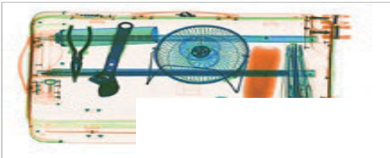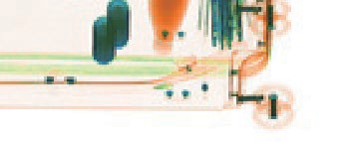

Introduction
Highlights
Dual-view technology
Widely usable for carry-on baggage Identify overlapping items easily
Standard
Fingerprint console board Dual monitor operation desk Bi-directional scanning
Optional
Face recognition Energy saving function Rat expelling function Video surveillance
ZKX6550D is a dual view x-ray security inspection equipment. ZKX6550D could display horizontal and vertical images by two independent generators, and could detect organic, inorganic or mixtures quickly according to the effective atomic number of objects those are been detected. ZKX6550D could identify overlapping items and contraband easily and precisely.
ZKX6550D X-ray inspection system increases the operator’s ability to identify potential threats; the device is designed to scan carry-on baggage. ZKX6550D uses reliable high quality X-ray generator and the superb image algorithm.

ZKX6550D has innovative biometric identify function for operators, improving the security of system and preventing operator from forgetting password.

With ergonomic modern design, ZKX6550D could help operators to identify suspicious items fast and accurately.

Specifications

Tunnel Size | W650mm × H500mm
Speed | 0.20 m/s
Height of Transmission Belt | 800 mm
Maximum Load | ≤180 kg (Adequate distribution)
Wire Resolution | Bottom Generator: 38AWG\Side Generator: 38AWG
Space Definition | Horizontal Φ1.0mm \ Vertical Φ2.0mm
Penetrate Definition | Bottom Generator: 32AWG\Side Generator:32AWG
Penetration | Bottom Generator: 38mm\Side Generator: 38mm
Monitor | 21.5 inch LED x 2
System Function | High density alert, Explosive/ Drug auxiliary detect, TIP, Luggage counter, date/time display, User management, Training.
Film Safety | ASA/ISO1600 standard of film safety
X-ray System

Tube Voltage | 140KV
Cooling | Seal oil cooling / 100%
Single Inspection Dosage Rate | ≤1.0 µ Gy
Radiation Leak Dosage | 0.1 µ Gy/h (5cm from the surface)
Installation Specification

Size | L2350mm × W1320mm × H1332mm
Package Size | L2500mm × W1600mm × H1550mm
Console Desk Size | L1320mm × W900mm × H1320mm
Package Weight | 1000KG+135KG (Console desk)
Power Consumption | 1.5 kVA
Noise | 55 dB(A)
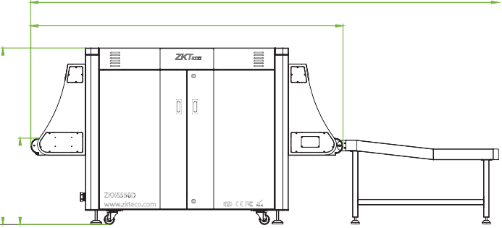
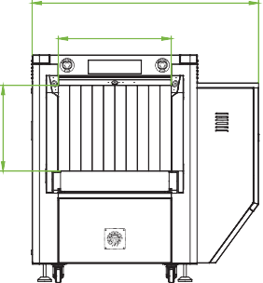
Dimension
3515
2350
1320
650
500



V1.1 2022.06.18
1332
650

ZKTECO CO.,LTD. www.zkteco.com E-mail: sales@zkteco.com
Copyright © 2022 ZKTECO CO., LTD. All rights reserved.

