Dual View X-ray Inspection System ZKX100100D

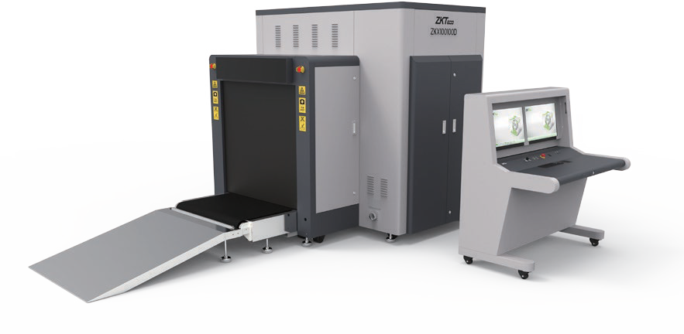
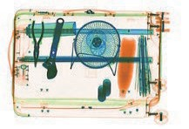
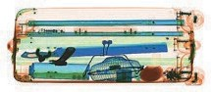
Introduction
Highlights
Dual-view technology
Widely usable for carry-on baggage Identify overlapping items easily
Standard
Fingerprint console board Dual monitor operation desk Bi-directional scanning
Optional
Face recognition Energy saving function Rat expelling function Video surveillance
ZKX100100D is a dual view x-ray security inspection equipment. ZKX100100D could display horizontal and vertical images by two independent generators, and could detect organic, inorganic or mixtures quickly according to the e ective atomic number of objects those are been detected. ZKX100100D could identify overlapping items and contraband easily and precisely.

ZKX100100D X-ray inspection system increases the operator’s ability to identify potential threats; the device is designed to scan large size baggage. ZKX100100D has innovative biometric identify function for operators, improving the security of system and preventing operator from forgetting password.

With ergonomic modern design, ZKX100100D could help operators to identify suspicious items fast and accurately.


Sp cations
300

Tunnel Size | W1018mm × H1010mm
Speed | 0.20~0.40 m/s
Height of Transmission Belt | 300 mm
Maximum Load | ≤200 kg (Adequate distribution)
Wire Resolution | Top Generator: 36AWG\Side Generator: 36AWG
Space De nition | Horizontal Φ1.6mm \ Vertical Φ1.6mm
Penetrate De on | Top Generator: 30AWG\Side Generator:30AWG
Penetration | Top Generator: 32mm\Side Generator: 32mm
Number of Colors in X-ray Image | 4
Monitor | 21.5 inch LED x 2
System Function | High density alert, Explosive/ Drug auxiliary detect, TIP, Luggage counter, date/time display, User management, Training.
Film Safety | ASA/ISO1600 standard of lm safety
X-ray System

Tube Voltage | 150KV
Cooling | Seal oil cooling / 100%
Radiation Leak Dosage | 0.5 µ Gy/h (5cm from the surface)

Installation Spe cation

Size | L3400mm × W1785mm × H1835mm
Package Size | L2850mm× W1950mm× H2050mm
Console Desk Size | L1320mm × W900mm × H1320mm
Package Weight | 1700KG+135KG (Console desk)
Power Consumption | 1.5 kVA
Noise | 55 dB(A)

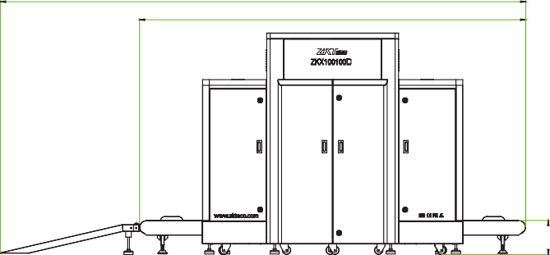
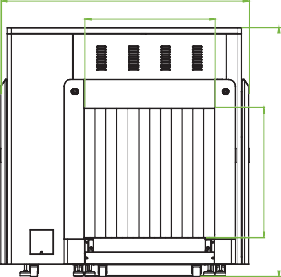
Dimension
4620
3400
V1.3 2024.05.30
ZKTECO CO.,LTD. www.zkteco.com E-mail: sales@zkteco.com
Copyright © 2024 ZKTECO CO., LTD. All rights reserved.
1785
1000
1000
1835



