

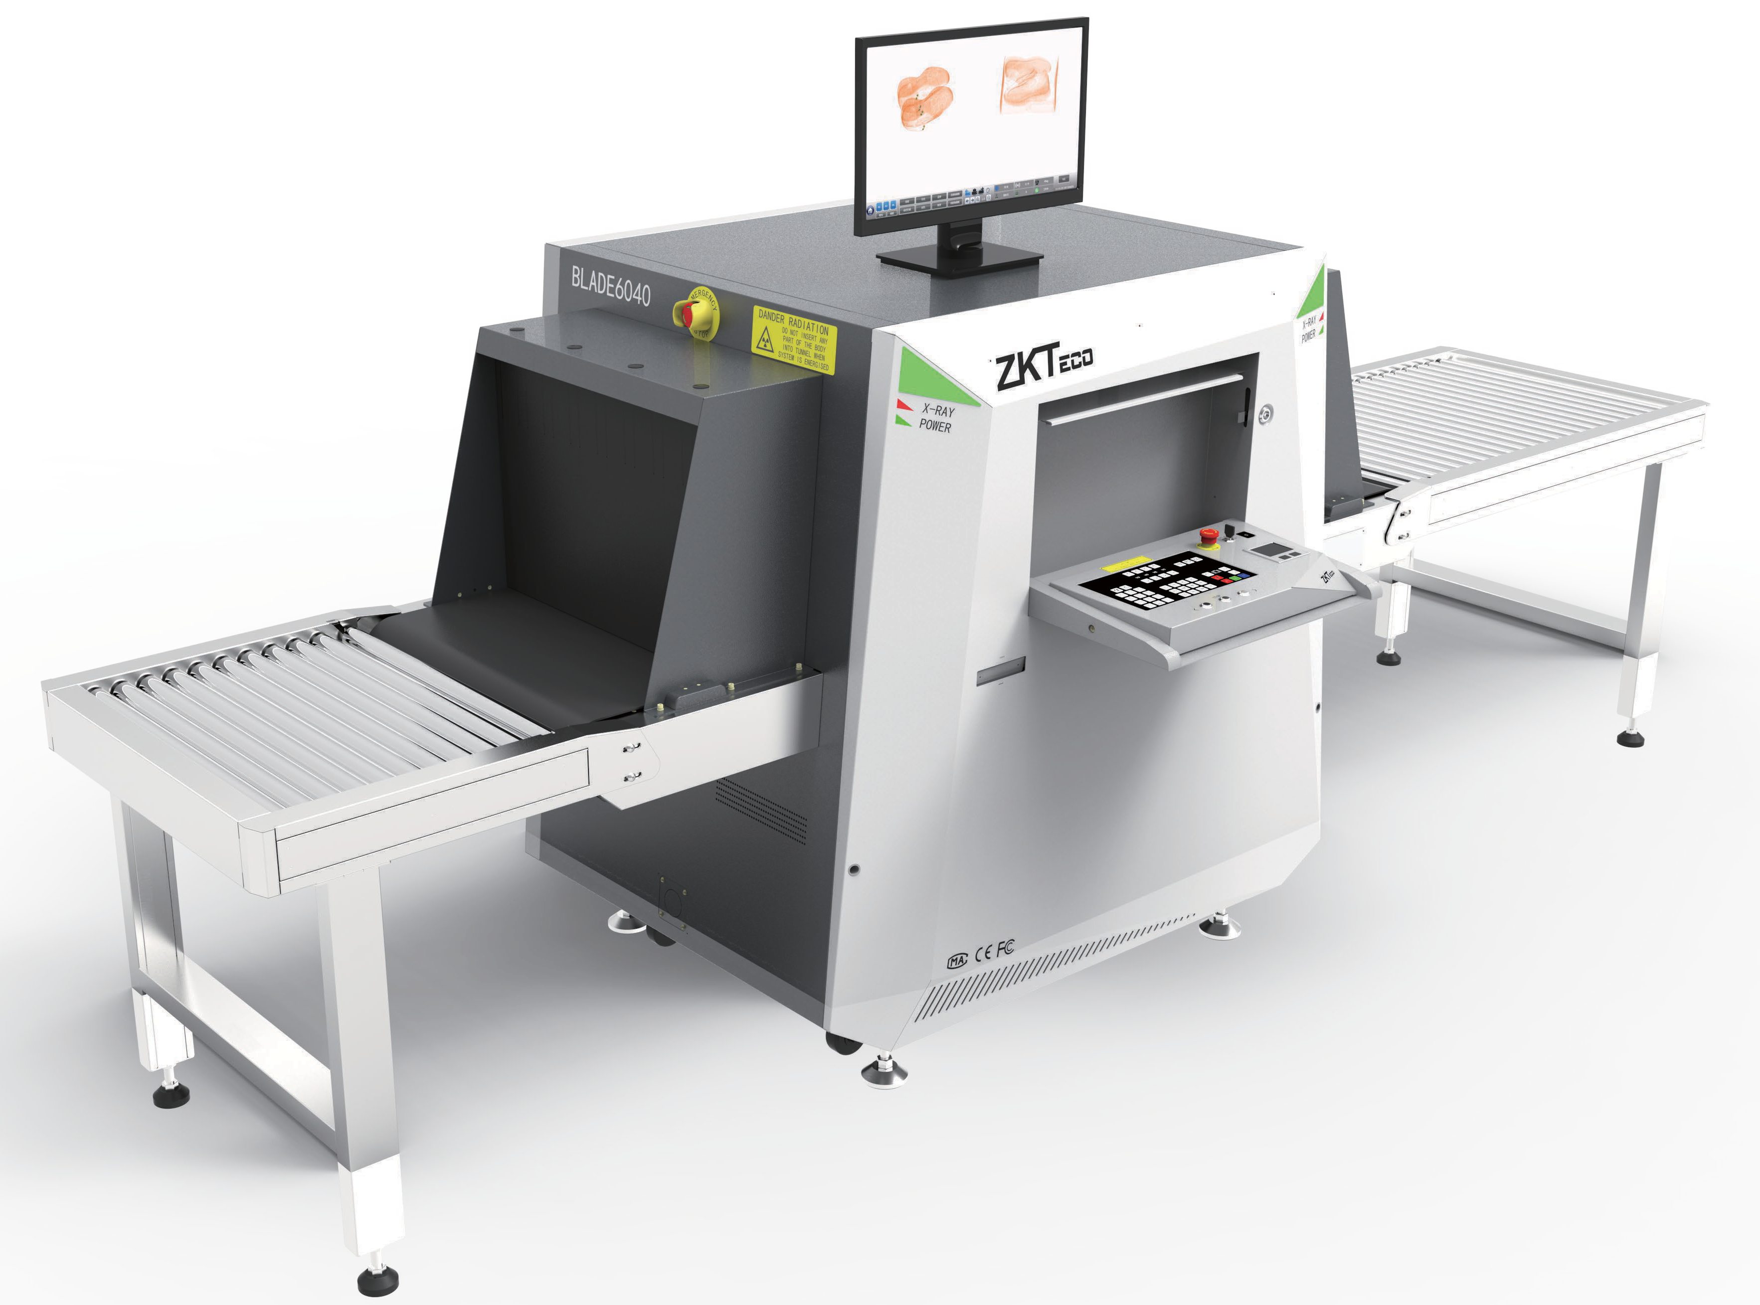

BLADE6040
Screener Assist
X-ray Baggage Inspection Systems

BLADE6040 is a X-ray baggage inspection which has a tunnel size of 610 mm by 420 mm and can provide the e ective inspection of mail, hand-held baggage, luggage and other items. It allo weapons,liquids, explosives, drugs, knives re guns, bombs, toxic substances s, ammunition, and dangerous objects, which are safety hazard b ective atomic number.
High image quality in combination with aut cts allows the operator to quickly and e ectively evaluate any luggage content.

Features Options

- Real-time Detection to Aid Operators in Identifying Suspicious
- High Performance – Typical Penetration up to 40 mm of Steel
- Startup with Fingerprint
- Four Layers of Lead Curtain
- Uninterruptible Power Supply
- Equipped with Input & Output Rollers
- Adjustable Conveyor Speed
- Real Time Remote Monitoring System
- Luggage Image and Walk Through Metal Detector Status Display on the Same Screen
- Threat Image Projection (TIP)
- Operator Desk
- Video Surveillance
- Gray Paint
- Guard Plate of Rollers (Two layers of lead curtain)
- Eyes on Function (Eye tracking technology to fol low the users eye as they operating x-ray inspec tion.There will be a prompt when the operator’s eyes leave the screen.)


( GL Exclusive Feature)

Technical Characteristics:
Tunnel Dimensions(W*H): 610mm*420 mm Conveyor Speed: 0.20 m/sec ~ 0.40m/sec Load on Conveyer:
Max 200 kg (Evenly Distributed)
HorizontalΦ1.0mm VerticalΦ1.0mm Steel Penetration: 38mm Guaranteed; 40mm Typical
Wire Resolution: 38AWG Guaranteed; 40AWG Typical
Dual-energy detector: Yes
Number of Colors in X-ray Image: 3 Dimensions(L*W*H): 1987.5*1023.9*1317mm
Package Dimensions(L*W*H): 2100mm*1200mm*1600 mm Package Weight: 750kg
Film Safety: ASA/ISO1600 standard of lm safety Single Inspection Dosage Rate: ≤1.0µGy Radiation Leak Dosage 0.1µ Gy/h (5cm from the surface)

Dimensions (mm)

Operating Environment:
Operating Temperature: -10°C to +45°C Storage Temperature: -20°C to +60°C Humidity: 5-95%, non condensing
Power Supply:230 VAC +/- 10% / 60/50 Hz (EU) 110 VAC +/- 10% / 60/50 Hz (US)
Power Consumption: 700W Sound Pressure: <51.8dB (A)

X-ray Generator:
Tube Current: 0.5-1.0 mA(adjustable) Anode Voltage: 150-170 kV(adjustable) Generator Cool: Seal oil cooling / 100%

Computation:
Processor: I7-7700 Monitor: 21” LED color Memory: 8 GB DDR4
Hard Drive: 240GB SSD+2TB HDD
Graphic Card: NVIDIA GeForce GTX 1660 Ti USB Port: 4 ports

Software features:
Perfect View (PV) Black / White (B/W) Pseudo Colors (PS) Inverse View (IN) High Penetration (HP)
Real Time Image Processing Image Zoom(128x)
Image of Previous Baggage Programmable Function Keys Baggage Counter
Date / Time Indicator
Threat Image Projection (TIP)
Automated threat identi cation software Platform software：ZKBio SIS
Monitor the status of walk through metal detector

ZKTECO CO.,LTD.
www.zkteco.com
E-mail: sales@zkteco.com


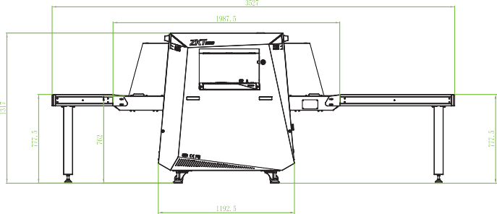
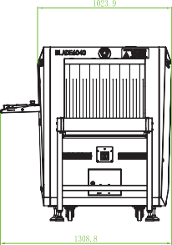
Copyright © 2023 ZKTECO CO., LTD. All rights reserved. V2.2 2023.12.11

