Dual Energy X-ray Inspection System ZKX10080

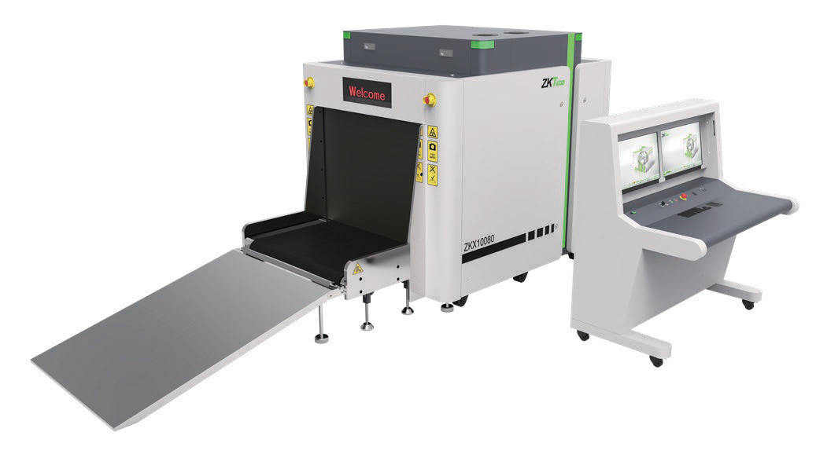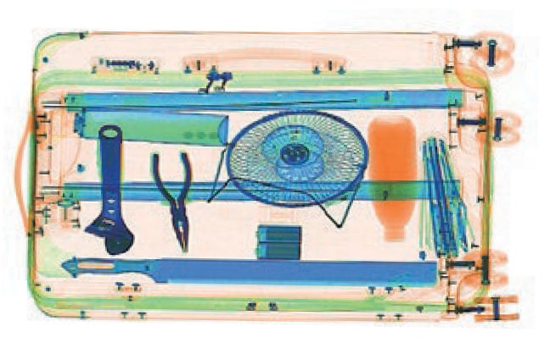

Introduction
Highlights
Adjustable belt speed
Large baggage and parcel screening Folding design for easy loading
Standard
Fingerprint console board Dual monitor operation desk Bi-directional scanning
Optional
Video surveillance Face recognition Energy saving function Rat expelling function

ZKX10080 X-ray inspection system increases the operator’s ability to identify potential threats; the device is designed to scan the objects up to a size of 100 × 80cm.

ZKX10080 uses reliable high quality dual energy X-ray generator. With the superb image algorithm, ZKX10080 could o er clear scanning image, which allows operators to identify potential threat items visually. Also, ZKX10080 equipped with a lowered conveyor height to make it easier to put the luggage on.

ZKX10080 has innovative biometric identify function for operators, improving the security of system and preventing operator from forgetting password.

The conveyor could be folded to reduce the package volume so that could save the transportation cost. With modern designed side door, the maintenance would be much easier.

Sp cations

Tunnel Size (W*H) | 1006*803 (mm)
Speed | 0.2-0.4m/s
Height of Transmission Belt | 385 mm
Maximum Load | 200 kg (Adequate distribution)
Wire Resolution | 38 AWG
Space De nition | Horizontal Φ1.0mm \ Vertical Φ2.0mm
Penetrate De on | 32 AWG
Penetration | 34mm steel board
Monitor | 21.5 inch LED X 2
System Function | High density alert, Explosive/ Drug auxiliary detect, TIP, Luggage counter, date/time display, User management, Training.
Film Safety | ASA/ISO1600 standard of lm safety
Supported Software | ZKBio SIS
Communication Interface | RJ45 (TCP/IP)
X-ray System

Tube Voltage | 150 KV
Cooling | Seal oil cooling / 100%
Radiation Leak Dosage | 0.2 µ Gy/h (5cm from the surface)
Installation Spe cation

Size (L*W*H) | 2984*1405*1666 (mm)
Package Size (L*W*H) | 2200*1500*1750 (mm)
Console Desk Size (L*W*H) | 1320*900*1320 (mm)
Package Weight | 1150KG+135KG (Console desk)
Power Consumption | 1 kVA
Noise | 53.8 dB(A)
Dimension
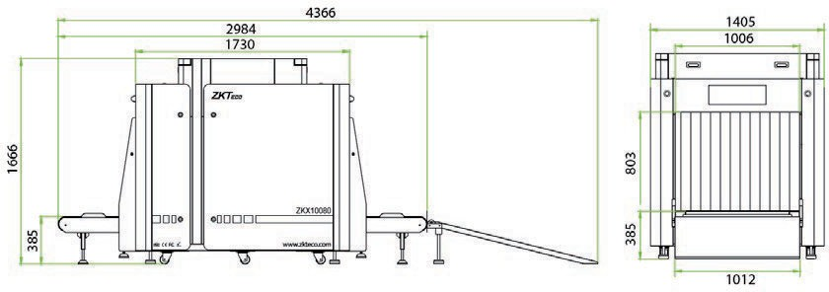
4280


V2.2 01/28/2024

ZKTECO CO.,LTD. www.zkteco.com E-mail: sales@zkteco.com
Copyright © 2024 ZKTECO CO., LTD. All rights reserved.

