Dual Energy X-ray Inspection System ZKX6550

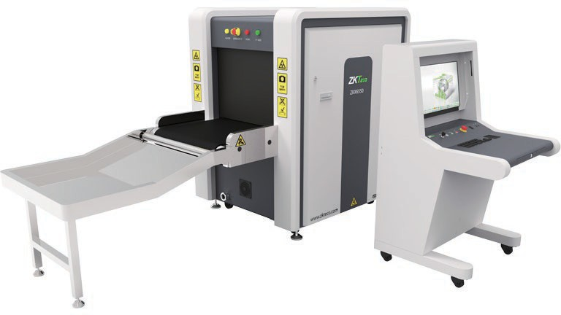

Introduction
Highlights
Offer higher Wire Resolution with high Performance X-ray detector True-color scanning image Innovative fingerprint identification
Widely usable for carry-on baggage
Standard
Fingerprint Console Board Console Desk Bidirectional Scan
Optional
Video surveillance system Gaze function
Rat expelling function

ZKX6550 X-ray inspection system increases the operator’s ability to identify potential threats; the device is designed to scan briefcases, carry-on baggage, small cargo parcels.

ZKX6550 uses reliable high quality X-ray generator. With the superb image algorithm, ZKX6550 could offer clear scanning image, which allows operators to identify potential threat items visually.

ZKX6550 has innovative biometric identify function for operators, improving the security of system and preventing operator from forgetting password.

With ergonomic modern design, ZKX6550 could help operators to identify suspicious items fast and accurately.

Specifications

Tunnel Size | W650mm × H500mm
Speed | 0.20 m/s
Height of Transmission Belt | 700 mm
Maximum Load | ≤180 kg (Adequate distribution)
Wire Resolution | 38 AWG (0.102mm metal wire)
Space Definition | Horizontal Φ1.0mm \ Vertical Φ2.0mm
Penetrate Definition | 34 AWG
Penetration | 38mm Steel board
Monitor | 21.5 inch LED
System Function | High density alarm, Explosive/Drug auxiliary detect, TIP, Luggage counter, System running timer, X-ray emitting timer, Training, 64 times continuous zoom in
Film Safety | ASA/ISO1600 standard of film safety
X-ray System

Tube Voltage | 140 KV
Cooling | Seal oil cooling / 100%
Single Inspection Dosage Rate | ≤1.0 µ Gy
Radiation Leak Dosage | 0.1 µ Gy/h (5cm from the surface)
Installation Specification

Size | L2120mm × W980mm × H1381mm
Package Size | L2240mm × W1170mm × H1755mm
Console Desk Size | L805mm × W900mm × H1320mm
Package Weight | 680KG+105KG (Console desk)
Power Consumption | 1 kVA
Noise | 53.8 dB(A)

Dimension

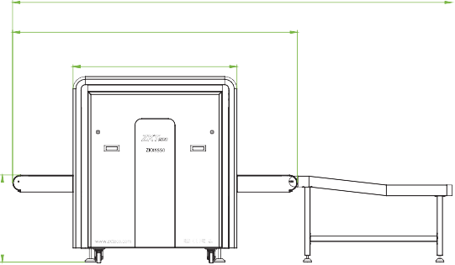
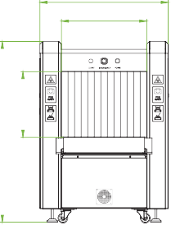
3275
2120

1220
980
650
1381
500



V1.2 2023.12.04
650

ZKTECO CO.,LTD. www.zkteco.com E-mail: sales@zkteco.com
Copyright © 2023 ZKTECO CO., LTD. All rights reserved.

