Dual Energy X-ray Inspection System ZKX5030C

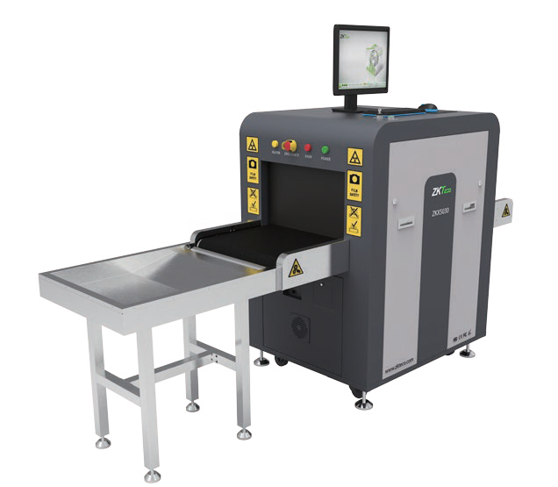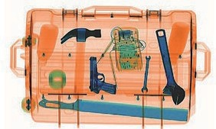

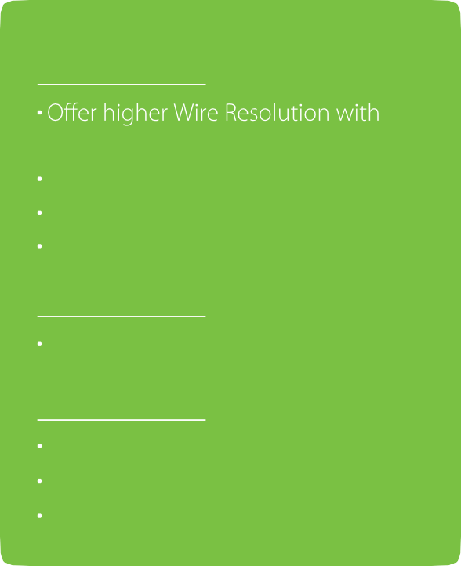
Introduction
Highlights
high Performance X-ray detector True-color scanning image Widely usable for small parcels
Excellent, ergonomic industrial design
Standard
Energy Saving Mode
Optional
Bidirection scan Fingerprint Console Board Console Desk

ZKX5030C X-ray inspection system increases the operator’s ability to identify potential threats; the device is designed to scan briefcases, carry-on baggage, small cargo parcels.

ZKX5030C uses reliable high quality X-ray generator. With the superb image algorithm, ZKX5030C could o er clear scanning image, which allows operators to identify potential threat items visually.

ZKX5030C has innovative biometric identify function for operators, improving the security of system and preventing operator from forgetting password.

With ergonomic modern design, ZKX5030C could help operators to identify suspicious items fast and accurately.

Sp cations

Tunnel Size | W507mm × H305mm
Speed | 0.20 m/s
Height of Transmission Belt | 730 mm
Maximum Load | ≤120 kg (Adequate distribution)
Wire Resolution | 36 AWG
Space De nition | Horizontal Φ1.0mm \ Vertical Φ2.0mm
Penetrate De nition | 32 AWG
Penetration | 32mm Steel board
Monitor | 21.5 inch LED
System Function | High density alarm, Explosive/Drug auxiliary detect, TIP, Luggage counter, System running timer, X-ray emitting timer, Training, 64 times continuous zoom in
Film Safety | ASA/ISO1600 standard of lm safety
X-ray System

Tube Voltage | 140 KV
Cooling | Seal oil cooling / 100%
Single Inspection Dosage Rate | ≤1.0 µ Gy
Radiation Leak Dosage | 0.1µ Gy/h (5cm from the surface)
Installation Sp cation

Size | L1701mm x W796mm x H1150mm
Package Size | L1900mm × W990mm × H1485mm
Package Weight | 450 KG
Power Consumption | 1 kVA
Noise | 53.8 dB(A)

Dimension

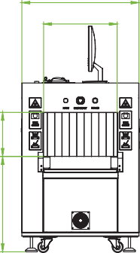
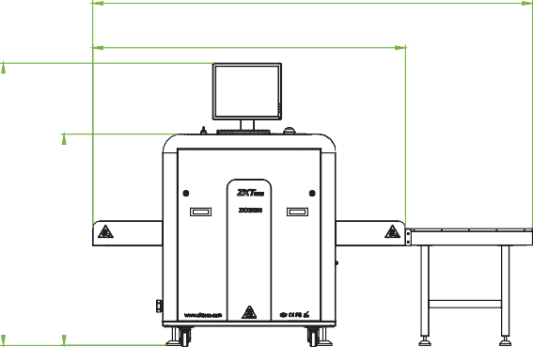
2391
796
500
1701
1535
300



V1.4 2024.03.25
1150
650
ZKTECO CO.,LTD. www.zkteco.com E-mail: sales@zkteco.com Copyright © 2024 ZKTECO CO., LTD. All rights reserved.

