Dual Energy X-ray Inspection System ZKX100100

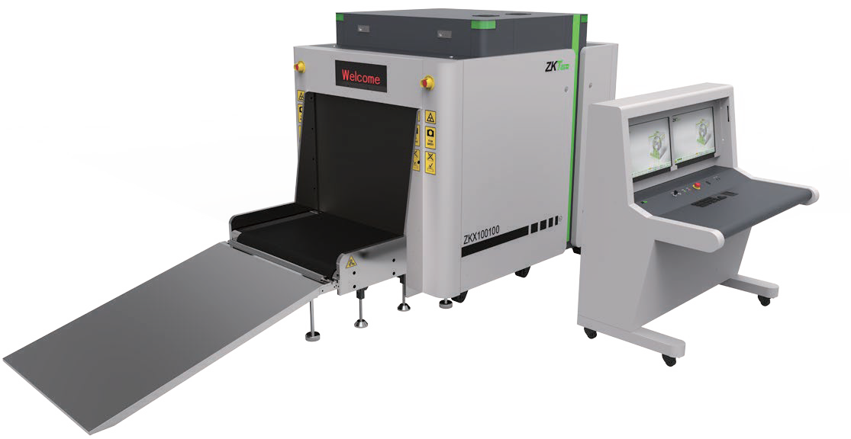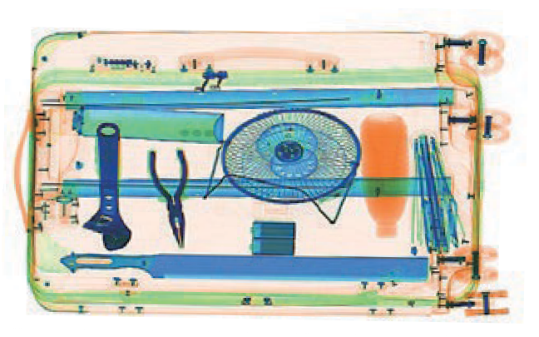

Introduction
Highlights
Adjustable belt speed
Large baggage and parcel screening Folding design for easy loading
Standard
Fingerprint console board Dual monitor operation desk Bi-directional scanning
Optional
Video surveillance Face recognition Energy saving function Rat expelling function

ZKX100100 X-ray inspection system increases the operator’s ability to identify potential threats; the device is designed to scan the objects up to a size of 100 × 100cm.

ZKX100100 uses reliable high quality dual energy X-ray generator. With the superb image algorithm, ZKX100100 could o er clear scanning image, which allows operators to identify potential threat items visually. Also, ZKX100100 equipped with a lowered conveyor height to make it easier to put the luggage on.

ZKX100100 has innovative biometric identify function for operators, improving the security of system and preventing operator from forgetting password.

With ergonomic modern design, ZKX100100 could help operators to identify suspicious items fast and accurately.

Spe cations

Tunnel Size(W*H) | 1000*1000(mm)
Speed | 0.2-0.4m/s
Height of Transmission Belt | 387 mm
Maximum Load | 200 kg (Adequate distribution)
Wire Resolution | 38 AWG
Space De nition | Horizontal Φ1.0mm \ Vertical Φ2.0mm
Penetrate De nition | 32 AWG
Penetration | 30 mm steel board
Monitor | 21.5 inch LED * 2
System Function | High density alert, Explosive/ Drug auxiliary detect, TIP, Luggage counter, date/time display, User management, Training.
Film Safety | ASA/ISO1600 standard of lm safety
X-ray System

Tube Voltage | 150 KV
Cooling | Seal oil cooling / 100%
Radiation Leak Dosage | 0.2 µ Gy/h (5cm from the surface)


Installation Spe cation

Dimension(L*W*H) | 3384*1407*1866(mm)
Dimension with packing(L*W*H) | 2600*1520*1920(mm)
Console Desk Dimension(L*W*H) | 1320*900*320(mm)
Weight with Packaging | Tunnel:1250kg Console Desk:135kg
Power Consumption | 1 kVA
Noise | 55.8 dB(A)
Dimension
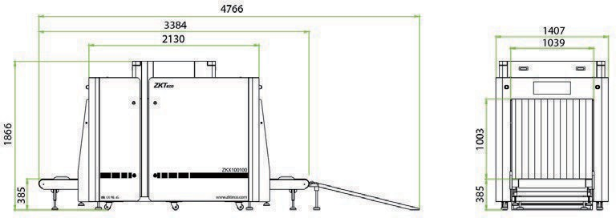
4684


ZKTECO CO.,LTD. www.zkteco.com E-mail: sales@zkteco.com

V2.3 01.23.2024


Copyright © 2024 ZKTECO CO., LTD. All rights reserved.

