ZKX6040
High-energy Hassle-free X-ray System

ZKX6040 is an advanced dual-energy X-ray baggage inspection assistant whose capabilities include penetration of up to 35mm of steel with an optimized algorithm. Its tunnel opening is as large as 600 mm by 400 mm.
ZKX6040 can detect organic matter, inorganic substances and mixture accurately in all kinds of packages according to the e ective atomic number of the examining objects.
B from the compact design with a foldable keyboard, ZKX6040 has high mobility and could be placed in hotels, government o ces, transportation hubs and other occasions.


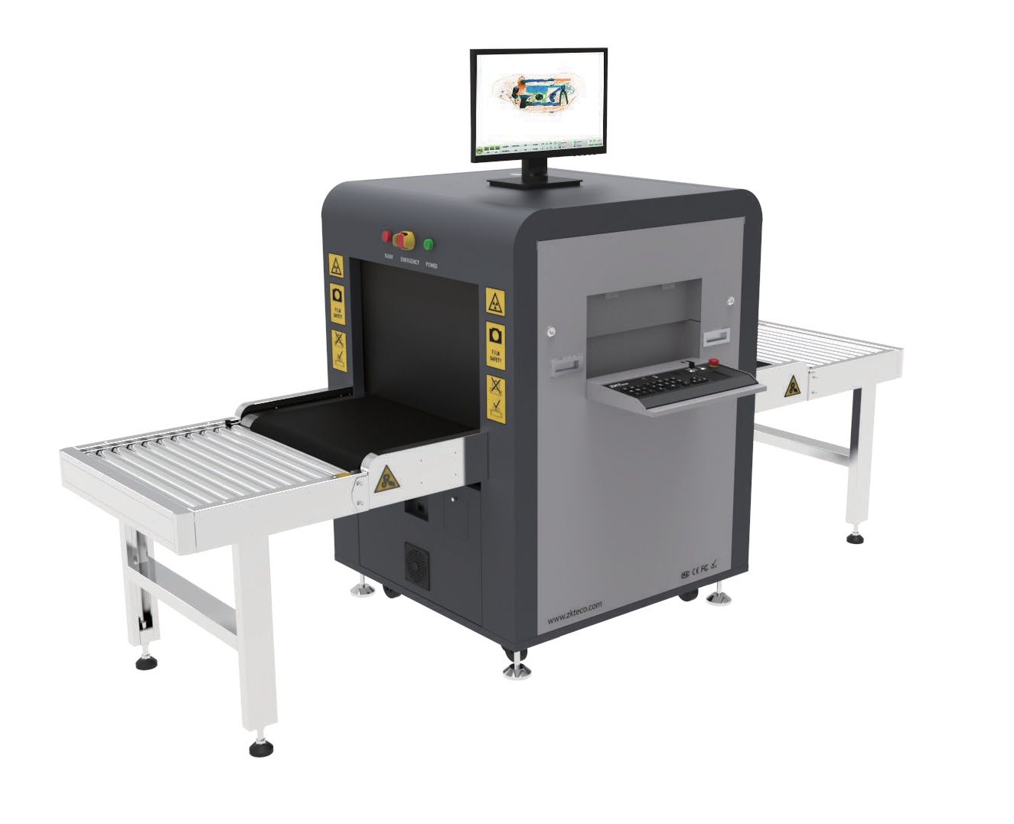
Features
Steel Penetration up to 35mm Foldable Keyboard
Veri on with Fingerprint
Display of Cluttered Bag Images together with the Status of the Walk-though Metal Detector
Input/Output Roller Conveyor

Options
Operator Desk
Uninterruptible Power Supply (UPS) Video Surveillance
Eye Tracker (eye tracking technology re ecting the position of the user's eyes and the gaze point on a screen as they are operating X-ray inspection. There will be a prompt when the operator’s eyes are o the screen.)

Software Features
Perfect View (PV) Black / White (B/W) Pseudo Colors (PS) Inverse View (IN) High Penetration (HP)
Real-time Image Processing and Image Zoom (64x) Image of Previous Baggage
Programmable Function Keys Baggage Counter
Date / Time Indicator
Threat Image Projection (TIP)

Speci cations

Technical Characteristics

Tunnel Dimensions (W*H) 600*400 (mm)
Conveyor Speed 0.3m/sec
Load on Conveyor 180kg (evenly distributed)
Conveyor Height 680 mm
HorizontalΦ1.0mm VerticalΦ2.0mm

Steel Penetration 35mm

Wire Resolution 38AWG

Dual-energy Detector Yes
Number of Colors in X-ray Image 3

Dimensions (L*W*H) 1701*910*1305 ( mm )
Package Dimensions (L*W*H) 2070*1150*1400 ( mm )
Weight 380 kg

Package Weight 480 kg
Film Safety
ASA/ISO1600 standard

Single Inspection Dosage Rate ≤1.0µGy

Supported Software ZKBio SIS

Communication Interface RJ45(TCP/IP)
Radiation Leak Dosage 0.1µ Gy/h (5cm from the surface)

Operating Environment

Operating Temperature -10°C to +45°C
Storage Temperature -20°C to +60°C
Humidity 5-95%, non-condensing
230 VAC +/- 10% / 60/50 Hz (EU)
Power Supply
110 VAC +/- 10% / 60/50 Hz (US)
Power Consumption Max. 1.0 kVA
Sound Pressure 54dB

Computer Speci cations

Intel® Braswell SoC N3160 (QC-2.24GHz)
Processor

Monitor 21” LED color
Memory Onboard 4 GB RAM
Hard Drive 2TB
USB Port 4 ports

Max. Storage Up to 200,000 scanned images

X-ray Generator

Tube Current 0.8 mA
Anode Voltage 150 kV rated
Generator Cool Seal oil cooling / 100%
Orientation Vertically upwards

Dimensions (mm)

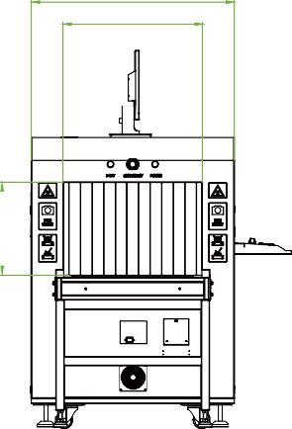
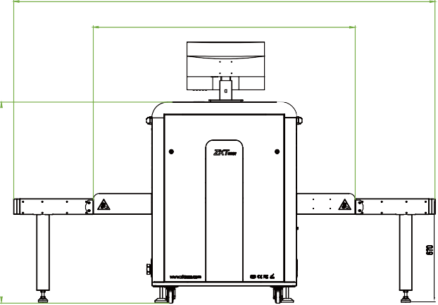
2736
910
600
1701
400


V4.1 12/11/2023
1305

ZKTECO CO.,LTD. www.zkteco.com E-mail: sales@zkteco.com Copyright © 2023 ZKTECO CO., LTD. All rights reserved.

