Dual Energy X-ray Inspection System ZKX10080D

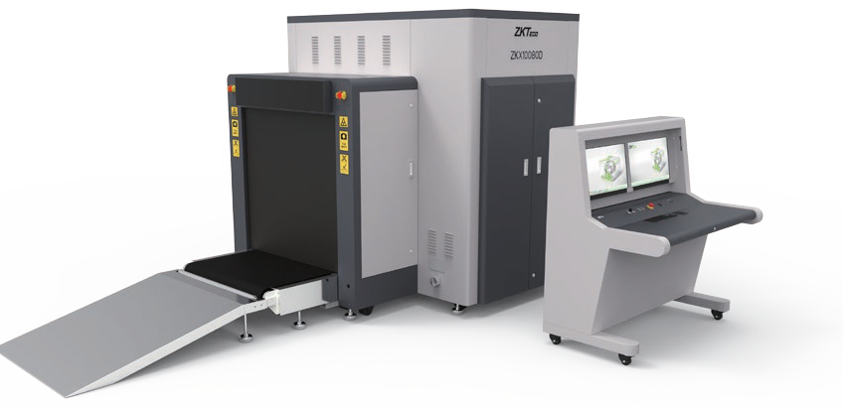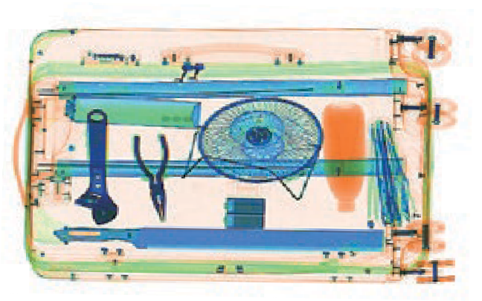

Introduction
Highlights
Adjustable belt speed
Large baggage and parcel screening Folding design for easy loading
Standard
Fingerprint console board Dual monitor operation desk Bi-directional scanning
Optional
Video surveillance Face recognition Energy saving function Rat expelling function

ZKX10080D is a dual view x-ray security inspection equipment. ZKX10080D could display horizontal and vertical images by two independent generators, and could detect organic, inorganic or mixtures quickly according to the effective atomic number of objects those are been detected. ZKX10080D could identify overlapping items and contraband easily and precisely.
ZKX10080D X-ray inspection system increases the operator’s ability to identify potential threats; the device is designed to scan large size baggage. ZKX10080D has innovative biometric identify function for operators, improving the security of system and preventing operator from forgetting password.
With ergonomic modern design, ZKX10080D could help operators to identify suspicious items fast and accurately.

Specifications

Tunnel Size | W1018mm × H822mm
Speed | 0.2 - 0.4 m/s
Height of Transmission Belt | 300 mm
Maximum Load | ≤200 kg (Adequate distribution)
Wire Resolution | Top Generator: AWG\Side Generator: AWG
Space Definition | Horizontal Φ1.6mm \ Vertical Φ1.3mm
Penetrate Definition | Top Generator: 3 AWG\Side Generator:3 AWG
Penetration | Top Generator: 3 mm\Side Generator: 3 mm
Number of Colors in X-ray Image | 4
Monitor | 21.5 inch LED X 2
System Function | High density alert, Explosive/ Drug auxiliary detect, TIP, Luggage counter, date/time display, User management, Training.
Film Safety | ASA/ISO1600 standard of film safety

X-ray System

Tube Voltage | 160 KV
Cooling | Seal oil cooling / 100%
Single Inspection Dosage Rate | ≤7.3 µ Gy
Radiation Leak Dosage | ≤0.5 µ Gy/h (5cm from the surface)
Installation Specification

Size | L3178mm × W1785mm × H1634mm
Package Size | L2900mm × W1900mm × H2000mm
Package Size of Console Desk | L1320mm × W900mm × H1320mm
Package Weight | 1570KG+135KG (Console desk)
Power Consumption | 1.5 kVA
Noise | 55 dB(A)

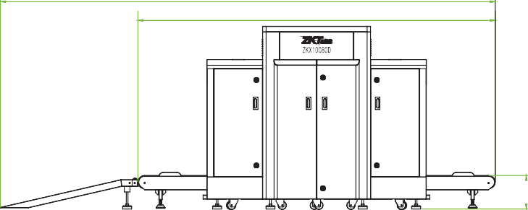
Dimension
4400
3178

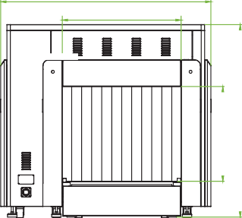
1785
1000
800
1634



V1.3 2023.04.04
300

ZKTECO CO.,LTD. www.zkteco.com E-mail: sales@zkteco.com
Copyright © 2023 ZKTECO CO., LTD. All rights reserved.

