
1

INSTALLATION GUIDE
- ray Inspection System ZKX5030

Version: V1.2 Date: 2018.02

Component disassembly
    - Open the side plate with the triangle key. Note that there are two positioning posts under the side panel. When removing the side panel, first lift the side panel and then remove it.

    - Use a wrench to remove the four fixed internal hexagon bolts counterclockwise.

    - Use a wrench to turn the four support feet under the device clockwise to disengage the device from the wood and then pull out the two support bars under the device. Use the wrench again to turn the four foot cups under the device counterclockwise until the wheels can move.

    - Move the equipment to the place of use, and cover the side covers on both sides. When closing, pay attention to the positioning of the positioning posts on the bottom and the holes in the side plates. Finally, twist the foot cup clockwise to ensure that the equipm ent is fixed well and locks the foot nut.

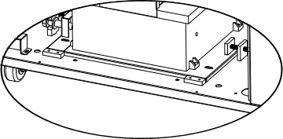
① ②
Fixing holes and bolts
Positioning
column

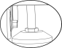
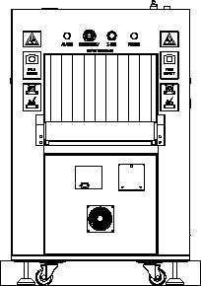
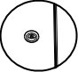
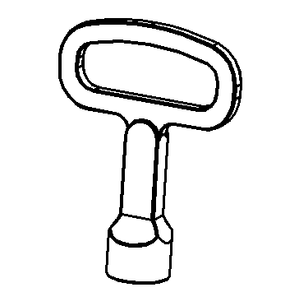
③
Support wood

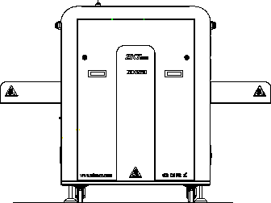
④

shelf connection
- Using 8 M6*16 inner six angle screw with the elastic gasket, connect the two H frame with the beam together.

- Using 16 M6*16 inner six angle screw with the elastic gasket, connect H frame with the receiving tray together.

- Put the roller on the fixed seat.

- Using 4 M6*8 countersunk head screws， connect graft connecting piece with machine frame.

- Using 4 M6*8 with countersunk head screw ,connect device with receiving shelf.

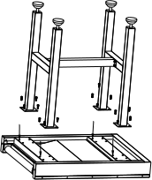
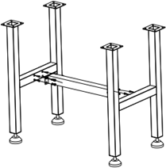
① ②

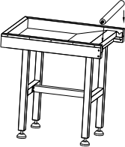
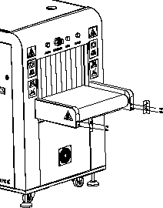
③ ④

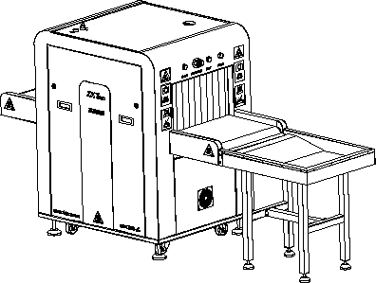
⑤

wiring

- Take the monitor from the package and install the screen and base.

- Take the wireless keyboard and mouse and their USB receiver from it’s package and install battery.

- Connect the VGA cable and monitor power cable on the top plate to the monitor. The receiver can be connected with any one of USB estension cable.

- Insert the power cable into the external port of the device and plug the other end into the electric supply.

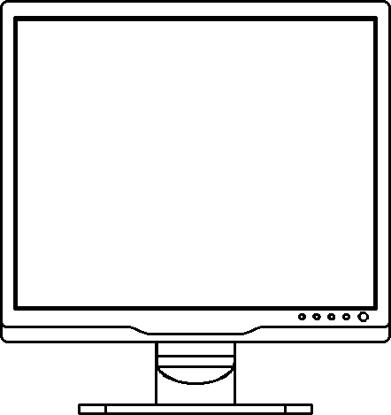
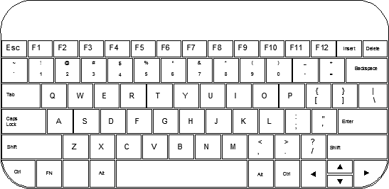
①
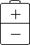
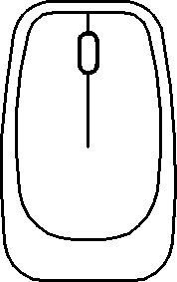

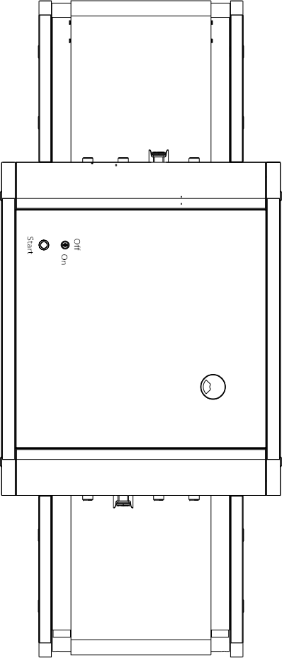
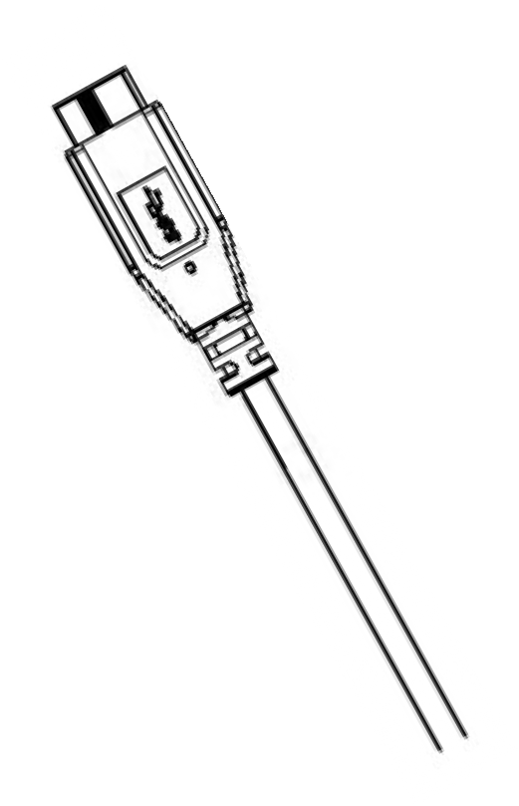
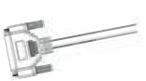
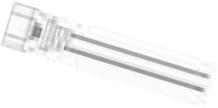
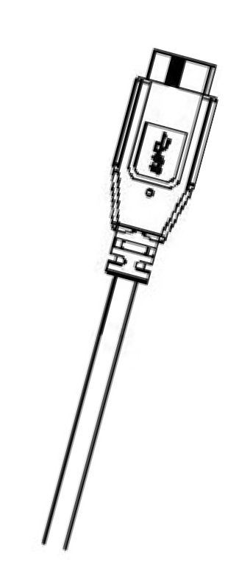
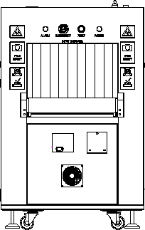
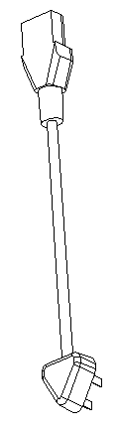
Connect the electric supply cable triangle plug

USB

Power cable
VGA cable
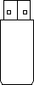
Receiver

Boot
- After checking the line, you can directly use the key to turn the switch to "ON", then press the start button and wait for the device to start.

- The initial login is automatically logged in as administrator by default. The default admin account and password are: user name: 9999, password: 123456. Please change the password as soon as possible afte

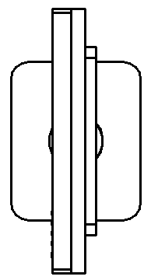
① ② 3.
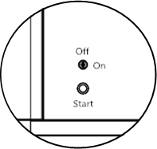
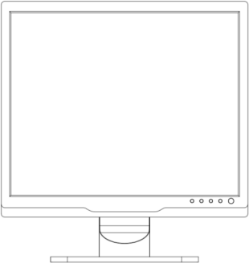


Check the 


- Place the package on the belt at the entrance and use the mouse to click on the arrow keys to control motor.

- After the parcel is conveyed to the goods shelves by the belt, the image appears on the screen in real time, and the selected image processing function can be d in the image.

- Use the mouse to click on the "  " button in the control key. After the motor stops running, remove the package from the shelves.

Place parcels, motor control keys
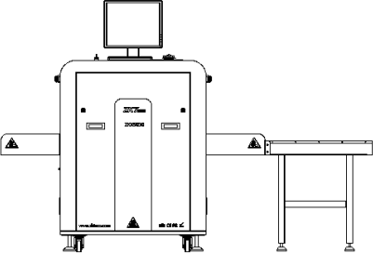
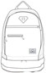

① ②

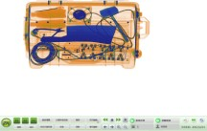
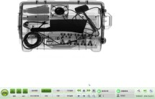


Power off
5
ZK Building, Wuhe Road, Gangtou, Bantian, Buji Town, Longgang District, Shenzhen China 518129
Tel: +86 755-89602345
Fax: +86 755-89602394
www.zkteco.com
© Copyright 2014. ZKTeco Inc. ZKTeco Logo is a registered trademark of ZKTeco or a related company. All other product
and company names mentioned are used for.

- When turned off, you need to turn the key switch from "ON" to "OFF". Note that do not unplug the power cable until the machine is shut down completely.

- The device shows "Shutdown" and then prompts "Windows will shut down within one minute." When the green work indicator goes out, the device is completely turned off.

- After the equipment is completely turned off, the mains electricity can be disconnected. Please remove the key on the key switch and keep it properly.

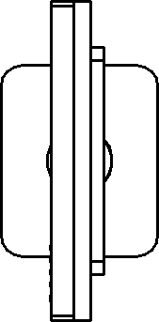
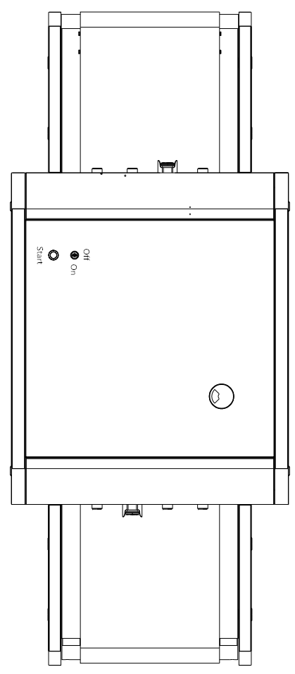
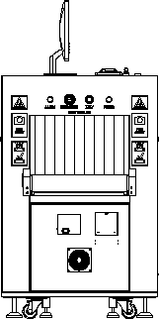
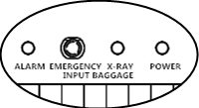
① ②

③

