


X-Ray Inspection System User Manual

P a g e | 1 Copyright©2020 ZKTECO CO., LTD. All rights reserved.

User Manual
X-Ray Inspection System
Applicable models: ZKX5030A/ZKX5030C/ZKX6040/ZKX6550A/ZKX6550C/ ZKX6550D/ZKX10080/ZKX10080D/ZKX100100/ZKX100100D
Date: April 2021
Doc Version: 3.2 English

Thank you for choosing our product. Please read the instructions carefully before operation. Follow these instructions to ensure that the product is functioning properly. The images shown in this manual are for illustrative purposes only.

For further details, please visit our Company’s website www.zkteco.com.

Copyright © 2021 ZKTECO CO., LTD. All rights reserved.

Without the prior written consent of ZKTeco, no portion of this manual can be copied or forwarded in any way or form. All parts of this manual belong to ZKTeco and its subsidiaries (hereinafter the "Company" or "ZKTeco").

Trademark

is a registered trademark of ZKTeco. Other trademarks involved in this manual are owned by their respective owners.

Disclaimer

This manual contains information on the operation and maintenance of the ZKTeco equipment. The copyright in all the documents, drawings, etc. in relation to the ZKTeco supplied equipment vests in and is the property of ZKTeco. The contents hereof should not be used or shared by the receiver with any third party without express written permission of ZKTeco.
The contents of this manual must be read as a whole before starting the operation and maintenance of the supplied equipment. If any of the content(s) of the manual seems unclear or incomplete, please contact ZKTeco before starting the operation and maintenance of the said equipment.
It is an essential pre-requisite for the satisfactory operation and maintenance that the operating and maintenance personnel are fully familiar with the design and that the said personnel have received thorough training in operating and maintaining the machine/unit/equipment. It is further essential for the safe operation of the machine/unit/equipment that personnel has read, understood and followed the safety instructions contained in the manual.
In case of any conflict between terms and conditions of this manual and the contract specifications, drawings, instruction sheets or any other contract-related documents, the contract conditions/documents shall prevail. The contract specific conditions/documents shall apply in priority.

ZKTeco offers no warranty, guarantee or representation regarding the completeness of any information contained in this manual or any of the amendments made thereto. ZKTeco does not extend the warranty of any kind, including, without limitation, any warranty of design, merchantability or fitness for a particular purpose.
ZKTeco does not assume responsibility for any errors or omissions in the information or documents which are referenced by or linked to this manual. The entire risk as to the results and performance obtained from using the information is assumed by the user.
ZKTeco in no event shall be liable to the user or any third party for any incidental, consequential, indirect, special, or exemplary damages, including, without limitation, loss of business, loss of profits, business interruption, loss of business information or any pecuniary loss, arising out of, in connection with, or relating to the use of the information contained in or referenced by this manual, even if ZKTeco has been advised of the possibility of such damages.
This manual and the information contained therein may include technical, other inaccuracies or typographical errors. ZKTeco periodically changes the information herein which will be incorporated into new additions/amendments to the manual. ZKTeco reserves the right to add, delete, amend or modify the information contained in the manual from time to time in the form of circulars, letters, notes, etc. for better operation and safety of the machine/unit/equipment. The said additions or amendments are meant for improvement /better operations of the machine/unit/equipment and such amendments shall not give any right to claim any compensation or damages under any circumstances.
ZKTeco shall in no way be responsible (i) in case the machine/unit/equipment malfunctions due to any non-compliance of the instructions contained in this manual (ii) in case of operation of the machine/unit/equipment beyond the rate limits (iii) in case of operation of the machine and equipment in conditions different from the prescribed conditions of the manual.
The product will be updated from time to time without prior notice. The latest operation procedures and relevant documents are available on http://www.zkteco.com
If there is any issue related to the product, please contact us.

ZKTeco Headquarters

Address ZKTeco Industrial Park, No. 32, Industrial Road, Tangxia Town, Dongguan, China.
Phone +86 769 - 82109991

Fax +86 755 - 89602394

For business related queries, please write to us at: sales@zkteco.com. To know more about our global branches, visit www.zkteco.com.

About the Company

ZKTeco is one of the world’s largest manufacturer of RFID and Biometric (Fingerprint, Facial, Finger-vein) readers. Product offerings include Access Control readers and panels, Near & Far-range Facial Recognition Cameras, Elevator/floor access controllers, Turnstiles, License Plate Recognition (LPR) gate controllers and Consumer products including battery-operated fingerprint and face-reader Door Locks. Our security solutions are multi-lingual and localized in over 18 different languages. At the ZKTeco state-of-the-art 700,000 square foot ISO9001-certified manufacturing facility, we control manufacturing, product design, component assembly, and logistics/shipping, all under one roof.
The founders of ZKTeco have been determined for independent research and development of biometric verification procedures and the productization of biometric verification SDK, which was initially widely applied in PC security and identity authentication fields. With the continuous enhancement of the development and plenty of market applications, the team has gradually constructed an identity authentication ecosystem and smart security ecosystem, which are based on biometric verification techniques. With years of experience in the industrialization of biometric verifications, ZKTeco was officially established in 2007 and now has been one of the globally leading enterprises in the biometric verification industry owning various patents and being selected as the National High-tech Enterprise for 6 consecutive years. Its products are protected by intellectual property rights.

About the Manual

This manual introduces the operations of X-Ray Inspection System.

All figures displayed are for illustration purposes only. Figures in this manual may not be exactly consistent with the actual products.

Document Conventions

Conventions used in this manual are listed below: GUI Conventions
For Software
Convention | Description
Bold font | Used to identify software interface names e.g. OK, Confirm, Cancel
> | Multi-level menus are separated by these brackets. For example, File > Create > Folder.
For Device
Convention | Description
< > | Button or key names for devices. For example, press <OK>
[ ] | Window names, menu items, data table, and field names are inside  square brackets. For example, pop up the [New User] window
/ | Multi-level menus are separated by forwarding slashes. For example, [File/Create/Folder].

Symbols

Convention | Description
 | This implies about the notice or pays attention to, in the manual
 | The general information which helps in performing the operations faster
 | The information which is significant
 | Care taken to avoid danger or mistakes
 | The statement or event that warns of something or that serves as a cautionary example.

Table of Contents

- IMPORTANT SAFETY PRECAUTIONS 9
Safety Standard of Imaging films 9
Safety checks before Power-on 9
Basic Safety Rules 9
Radiation Protection 10
- PRODUCT INTRODUCTION 11
Working Principle 16
Product Technical Specifications/Basic Parameters 17
Product Features 20
Application Areas 20
- EQUIPMENT OPERATION 21
Power-on 21
Item Inspection 23
Shut Down 23
Indicator and Emergency Stop Button 23
Special Keyboard 26
PC KEYBOARD AND MOUSE 29
- IMAGE PROCESSING AND SOFTWARE OPERATION 31
Main Interface 31
System Software 31
Information Area 32
Operating function area 33
Image Processing Function 34
    - BW/CL( BLACK&WHITE ⇔ COLOR) 34
    - HP (HIGH PENETRATE) 35
    - LP(LOW PENETRATE) 35
    - PV(PERFECT VIEW) 35
    - OM(ORGANIC MATERIAL) 36
    - IM(INORGANIC MATERIAL) 36
    - IN(INVERSING) 36
    - ADJUSTING BRIGHTNESS 37
    - DS(DYNAMIC SCAN) 37
    - PS(PSEUDO-COLOR DISPLAY) 37
    - SUSPICIOUS ORGANICS ENHANCING FEATURE OF Z789 37
System Options 38
Image 38
    - IMAGE PREVIEW 38
    - IMAGE SETTING 40
User Management 42
    - ACCOUNT SETTING 43
    - CHANGE PASSWORD 44
    - AUTOMATIC LOGIN 45
Log Management 45
    - STARTUP LOG 45
    - SESSION LOG 46
    - X-RAY RADIATION LOG 47
TIP(Threat Image Projection) 47
    - TIP STRATEGY 49
    - TIP IMAGES 50
    - TIP EXAM QUERY 51
Training 52
    - PARAMETERS SETTING 52
    - OPERATION PANEL 52
    - TRAINING PROCEDURE 53
System Settings 53
    - INTELLIGENT IDENTIFICATION 53
    - KEYBOARD 54
    - COUNTER SETTING 55
    - OTHERS 56
System information 57
Log out and shutdown 58
- MAINTENANCE INSTRUCTIONS 59
Installation Environment 59
Daily Cleaning 59
    - OUTER SURFACE OF THE EQUIPMENT 59
    - INTERIOR OF THE EQUIPMENT 60
    - DISPLAY, SLOT OF PHOTOELECTRIC SENSOR AND CONTROL CONSOLE 60
Regular Inspections 61
    - INSPECTION OF PHOTOELECTRIC SENSOR 61
    - INSPECTION OF CONVEYOR 61
    - INSPECTION OF LEAD SHIELD AT THE ENTRANCE AND EXIT OF THE PASSAGE 62
    - INSPECTION OF X-RAY LIGHT INDICATOR AND POWER INDICATOR LIGHT 62
    - INSPECTION OF EMERGENCY STOP BUTTON 62
Storage Conditions and Notice 62
Troubleshooting 63

Important Safety Precautions



The X-Ray Inspection System works as per the safety regulations. To ensure the safety of users, read this manual carefully before operating the system.

Safety Standard of Imaging Films
The imaging films used in our X-Ray Inspection System adheres to ISO1600 safety standards.

Safety Checks before Power-on
Before the power is turned-on, make sure to carry out the following safety checks:
  - Check the lead film, do not operate the system if the film is broken or there is any gap.
  - Check if the photoelectric sensor is blocked.

  - Check if the transmission belt is deviated or stuck; ensure that there is no spike or filth.
  - Check if there are flaws on the Shell, Monitor, Console board and cable.

  - Ensure that the cover plate is properly installed.

Basic Safety Rules
To ensure safe operation of the X-Ray Inspection system, follow the safety rules given below:
- The Operator must know the relevant radiation protection rules and all the safety instruction rules.
- If you had not used the system for more than 6 months, check carefully before operating.
- Only the professional technician is allowed to perform installation, circuit connection and replacement of electrical components.

- Do not operate the system if the Shell/Cable/Transmission belt is broken.

- Only the professional technician can open the shell and inner parts.


- Do not modify or change any safety settings.

- No living thing shall be allowed to pass through the X-Ray Inspection system.

- Do not dip any part of the body into the tunnel when the system is running.

- Shut down the system immediately if any liquid flows into the system.

- Make sure all the circuit connections and ground connections are proper.

Radiation Protection
To ensure the safety of the operator and users, we have outlined a set of radiation protection measures that includes:
- Only when the Generator works on a high voltage, the machine will emit X-Ray. So, the machine will not emit any radiation on transportation or normal usage.
- Lead Boards are installed around the machine; Lead films are installed at the entry and exit to prevent X-Ray from leaking into the environment.
- The machine has an effective ground connection which prevents electric shocks to the operator.
- Overload Preventer, Overcurrent Preventer and Current leakage Preventer are mounted inside the machine.
- The machine also includes a safety-interlock; if it is switched off, the X-Ray generator will not be activated.

Product Introduction

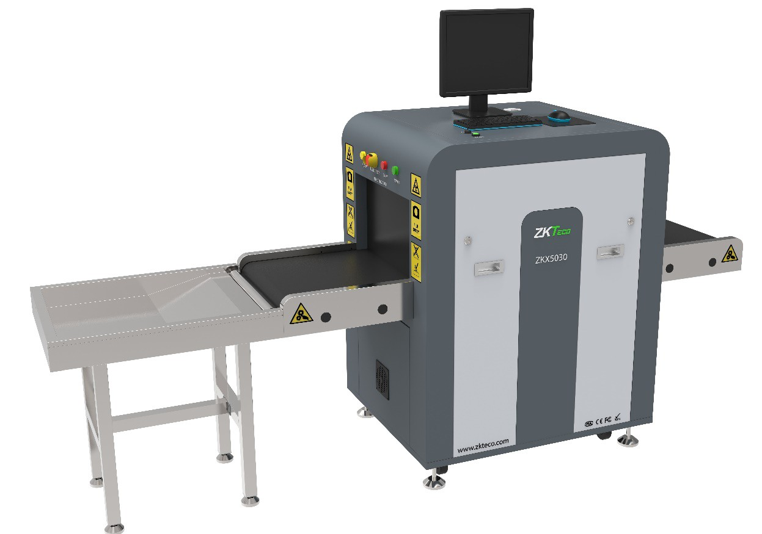
The X-Ray Inspection System offers a dependable and flexible intelligence security solution. We have built a comprehensive security system to protect your entrance, including People Inspection, Freight Inspection, and Vehicle Inspection. This chapter illustrates the working principle, product technical specifications, basic parameters, product features, and application areas.

ZKX5030A/ZKX5030C

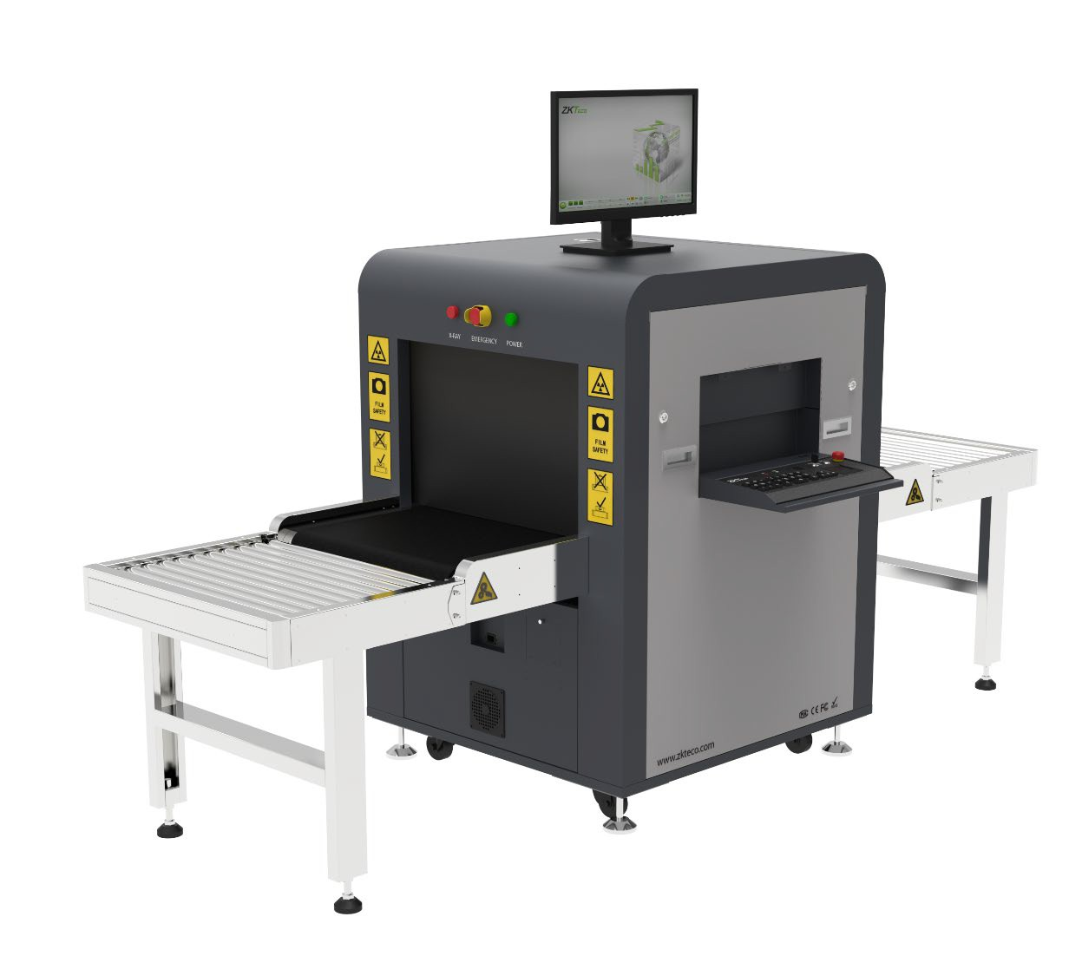
ZKX6040

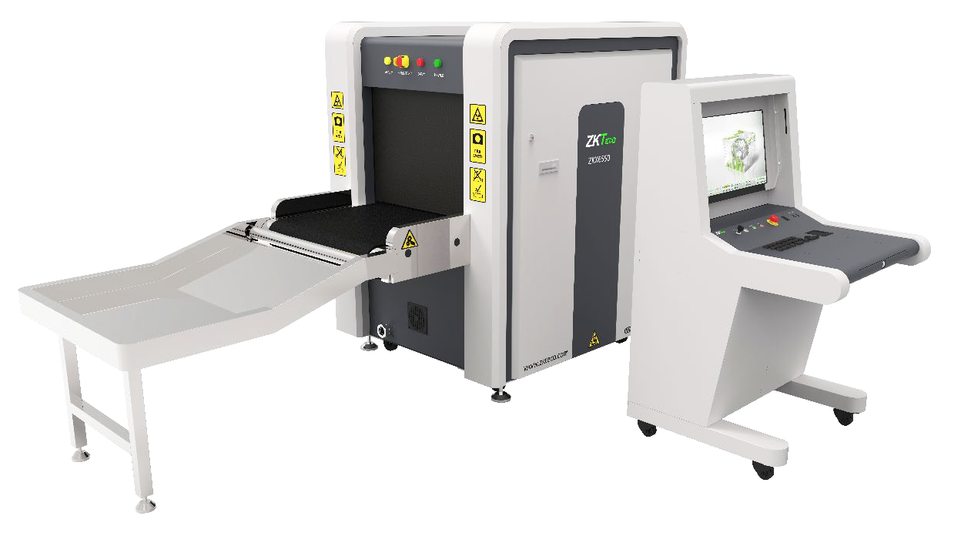
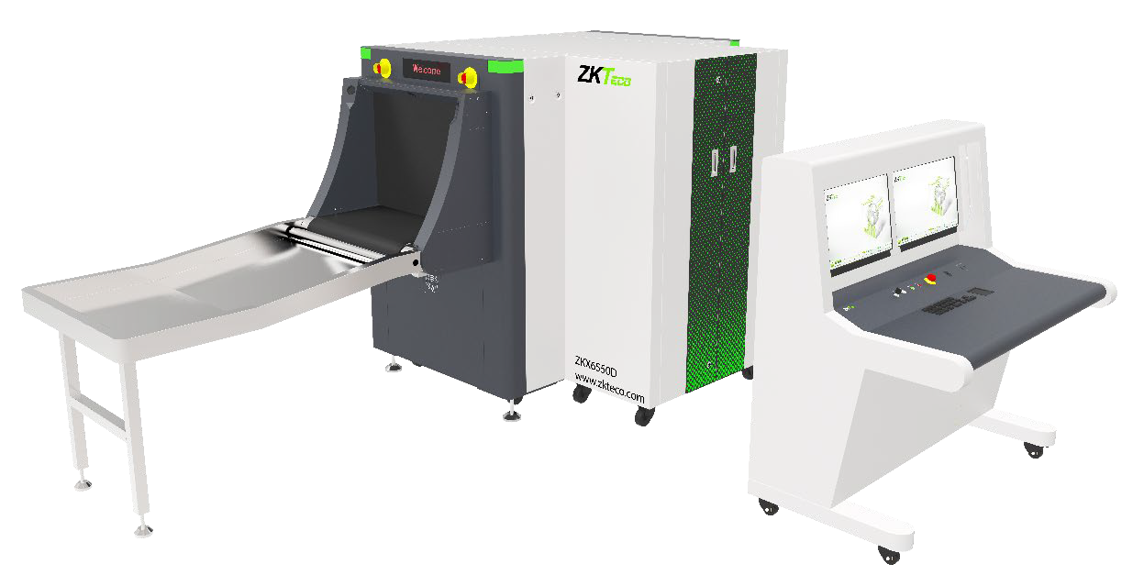
ZKX6550A/ ZKX6550C

ZKX6550D

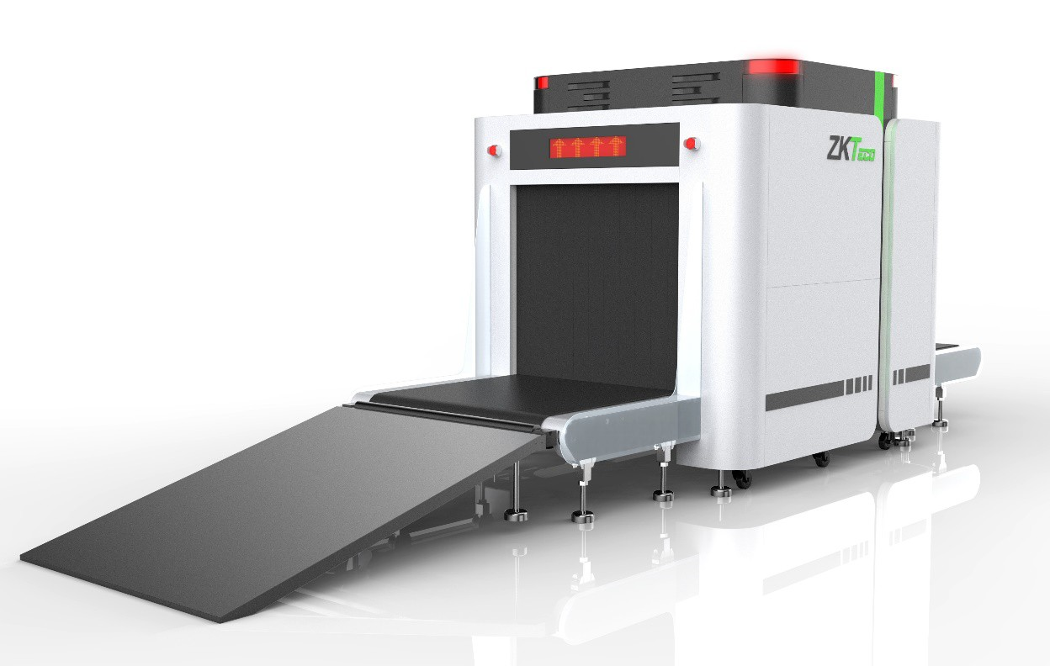
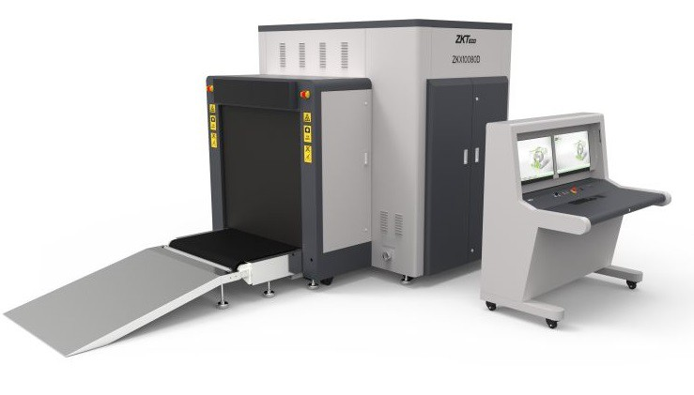
ZKX10080

ZKX10080D

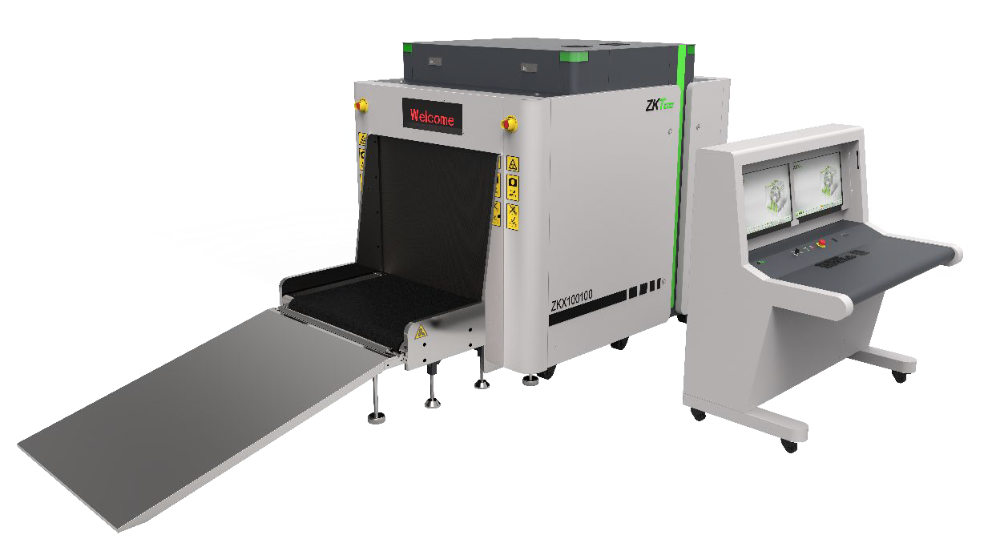
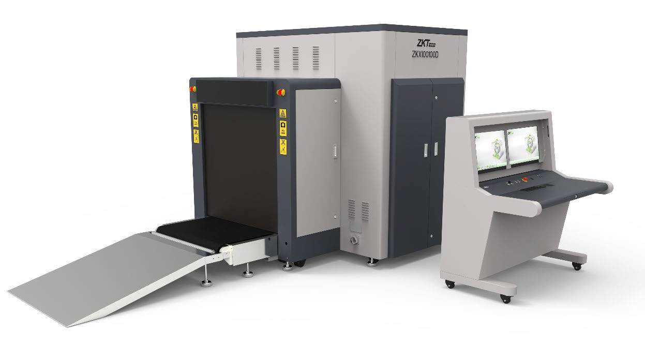
ZKX100100

ZKX100100D


Working Principle

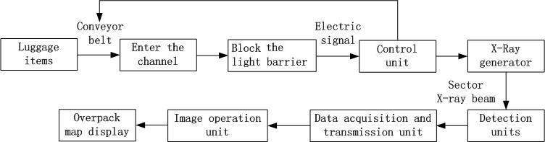
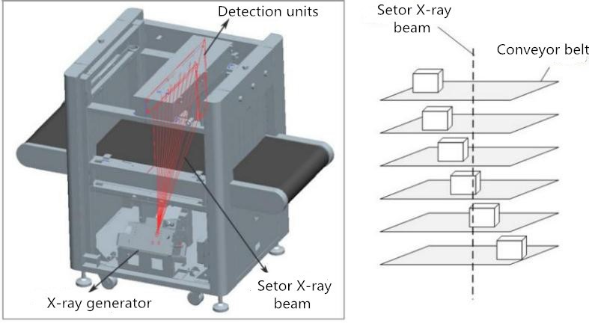
The X-Ray Inspection System has five modules: Item Transmission module, X-Ray Generator & Control, Signal acquisition & Transmission module, Industrial motherboard and Electric Control module.
The items enter the X-Ray inspection tunnel through the conveyor belt. A photo-electric sensor is installed at the entry of the tunnel. When the items enter into the tunnel, the sensor sends an inspection signal and the Control board commands the X-Ray Generator to generate X-Ray. The X-Ray penetrate through the items and it is partially absorbed by the items in the tunnel and the rest is absorbed by the X-Ray receiver. Then the receiver converts the X-Ray signal into digital signal and then sends to the computer. With the excellent image processing algorithm incorporated, a clear image of the items will be displayed on the screen.

Figure2-1 System Operation Process

Figure2-2 Equipment Internal X-Ray Diagram


Product Technical Specifications/Basic Parameters

Basic parameters of General series security inspection system
Model/Type |  |  | 5030A | 5030C | 6040 | 6550 | 10080 |  | 100100
 |  |  | Single energy | Dual energy | Dual energy | Dual energy | Dual energy |  | Dual energy
Basic parameters | Channel size | Width (mm) | 507 | 507 | 608 | 660 | 1004 |  | 1008
Basic parameters | Channel size | Height (mm) | 305 | 305 | 405 | 510 | 806 |  | 1005
Basic parameters | Maximum evenly distributed load(kg) |  | 150 | 150 | 150 | 180 | 220 |  | 220
Basic parameters | Tube current(mA) |  | 0.4 to 0.8 | 0.6 to 1.0
Basic parameters | Anode voltage |  | 80KV | 140KV to 160KV
Basic parameters | Cooling method |  | Sealed oil cold/100%
Environmental Parameters | Storage temperature/ relative humidity |  | -40±2℃ to +60±2℃/5% to 95%(Not condensed)
Environmental Parameters | Operating temperature/ relative humidity |  | 0℃±2℃ to +40±2℃/5% to 95%(Not condensed)
Environmental Parameters | Main Power Supply |  | AC220V(-15% to +10%),50Hz±3Hz
Environmental Parameters | Power loss (maximum) |  | ≤0.5KW | ≤0.5KW | ≤0.5KW | ≤0.8KW |  | ≤1.5KW | ≤1.5KW
Environmental Parameters | Noise level |  | ≤55dB
Image processing | Image Processing |  | Pseudocolor, gray color, high penetration, low penetration, super enhancement, mineral strip, organic

system |  |  | strip, dynamic scan, inverse image, etc.
system | Storage capacity |  | More than 100, 000 pictures
system | System functions |  | High density alert, drugs and explosives inspection, date/time display, baggage counting, user management, TIP, training and other functions.
Basic parameters of General series security inspection system
Model/Type |  |  | 6550D | 10080D | 100100D
 |  |  | Dual energy | Dual energy | Dual energy
Basic parameters | Channel size | Width (mm) | 660 | 1004 | 1008
Basic parameters | Channel size | Height (mm) | 510 | 806 | 1005
Basic parameters | Maximum evenly distributed load(kg) |  | 180 | 220 | 220
Basic parameters | Tube current(mA) |  | 0.6 to 1.0
Basic parameters | Anode voltage |  | 140KV to 160KV
Basic parameters | Cooling method |  | Sealed oil cold/100%
Environmental Parameters | Storage temperature/ relative humidity |  | -40±2℃ to +60±2℃/5% to 95%(Not condensed)
Environmental Parameters | Operating temperature/relati ve humidity |  | 0±2℃ to +40±2℃/5% to 95%(Not condensed)
Environmental Parameters | Main Power Supply |  | AC220V(-15% to +10%), 50Hz±3Hz

 | Power loss (maximum) | ≤1.0KW | ≤1.6KW | ≤1.6KW
 | Noise level | ≤55dB
Image processing system | Image Processing | Gray color, high penetrate, low penetrate, super  enhancement, mineral strip, organic strip, dynamic scan, inverse image, etc.
Image processing system | Storage capacity | More than 100, 000 pictures.
Image processing system | System functions | High density alert, drugs and explosives inspection, date/time display, baggage counting, user management, TIP, training and other functions.


Product Features


To ensure the users with a more secured, convenient and faster service, the inspection system is equipped with the following features:
- Environmental protection: There is a protective film on the surface of the lead shield to avoid touching and lead pollution.
- Secured assembly: The machine includes radiation emission control to avoid false emissions.
- One key shutdown: Turn off the key switch, the device automatically shuts down thus making it simple and convenient.
- Fault self-diagnosis: The system automatically identifies the failure and displays the message. So, it is easy to maintain.
- Special keyboard: It processes the image, boot, shuts down the machine and so on.
- Dynamic screen switching: Pictures can be switched between dynamic and static modes.

Application Areas
The X-Ray Inspection system adopts the latest image processing technology and high display resolution. The image will be clearer with a great resolution. It can quickly and effectively detect a variety of hazardous and high-density materials. It is suitable for small-size packages such as small bags, suitcases, bags and so on. It is used in Government sectors, Embassy's, Airports, Convention centers, Exhibition centers, Tourist places, Post offices, Shopping malls, Hotels and so on.

Equipment Operation


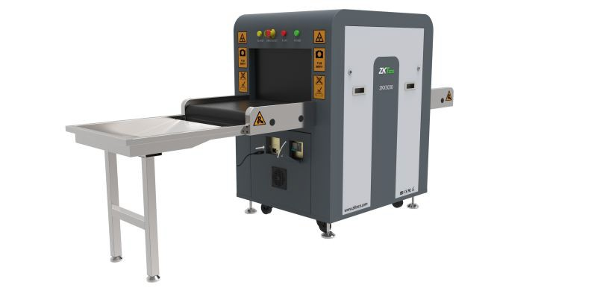
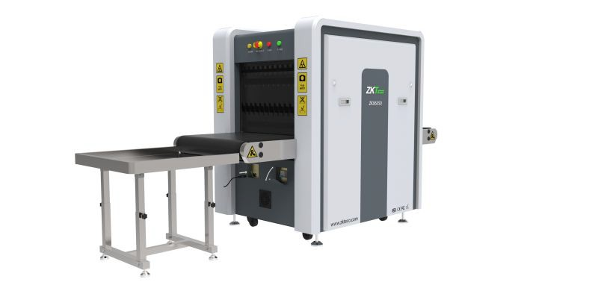
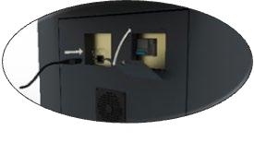

Power-on
Step 1: Plug the device power cable into the power outlet (make sure the power supply and the ground connections are proper).

Figure3-1 ZKX5030

Figure3-2 ZKX6550

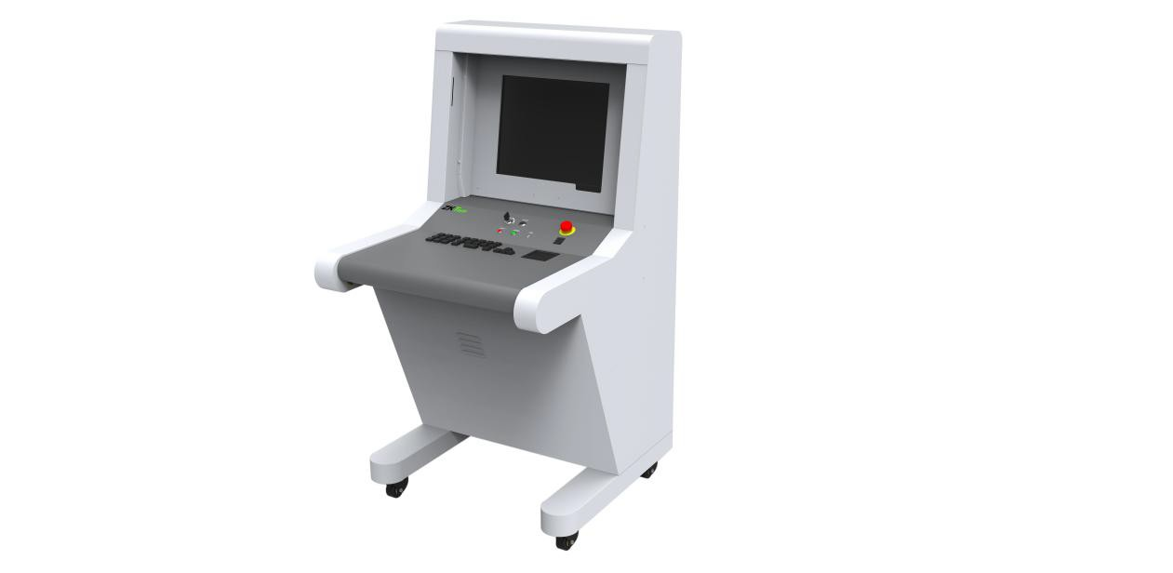
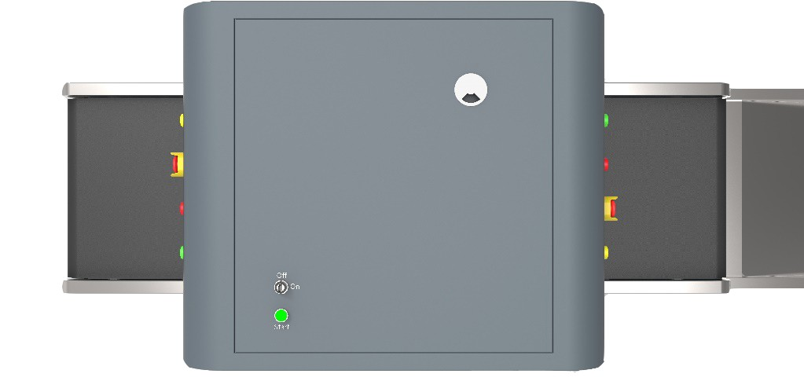
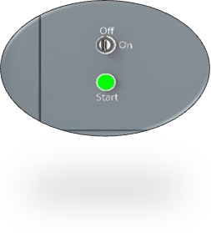
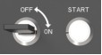
Step 2: Insert the key into the key slot and turn it on.

Figure3-3 Key slot in the ZKX5030

Figure3-4 Key slot in the control desk
Step 3: Press the Start button which is next to the key slot to start the system. The green light will glow.
Step 4: Once powered-on, the pre-heating process runs automatically to protect the X- Ray generator and it normally takes 1 to 5 mins. After preheating, the device starts to scan.


Item Inspection


Placing materials: The objects must be placed on the conveyor belt or the conveyor roller as indicated on the entry as "INPUT BAGGAGE".
Item inspection: When an item goes into the tunnel, the monitor will display the scanned image of the item. Different colors indicate different materials. The direction keys on the console board or the software interface controls the moving direction of the conveyor belt.
Step 1: Place the item at the tunnel entrance.
Step 2: Press the “Forward” button.
Step 3: When the item goes through the tunnel, the X-Ray indicator (red light) turns on.
Step 4: Finally remove the item after scanning.

Shut Down
Step 1: Stop running the conveyor belt, turn the key to the “OFF” position. The indicator on the right-side of the key slot will turn off and the green indicator will turn off after a minute.
Step 2: Disconnect the device from the external power supply. Take out the key from the key slot.

Indicator and Emergency Stop Button
Emergency stop button: If there is any emergency, press the Emergency stop button to stop the X-Ray emission and conveyor belt.




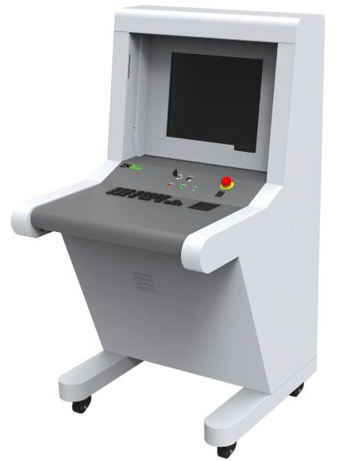

Figure3-5 Restore operation
Notice: If you need to restore the normal state of the device (cancel the emergency stop state), please rotate the pressed emergency stop button clockwise, pop it out, and then press the start button to resume.

Figure3-6 Restore operation
Note: Press the Start button to restore the operation.

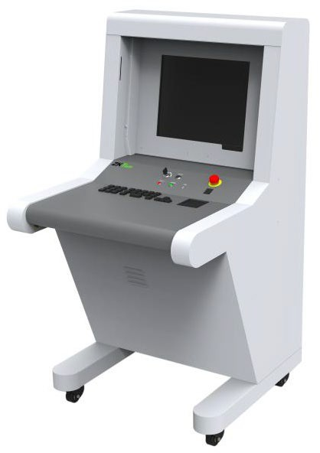
Figure3-7 Start button

Figure3-8 Start button
Operation Indicator (green): When the device is turned on, the green indicator will glow.
X-Ray Indicator (red): When the device is emitting X-Ray, the red indicator will glow.

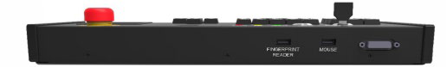
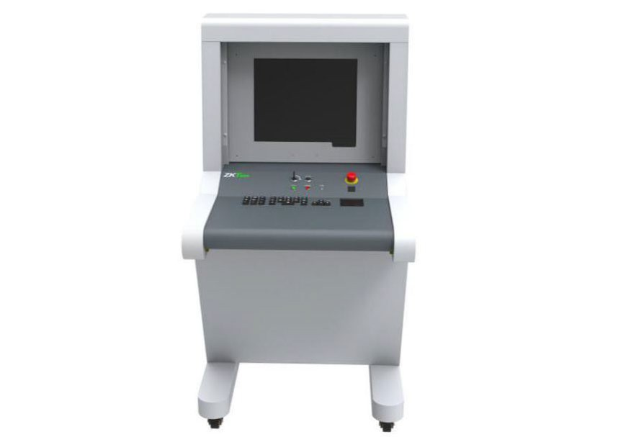
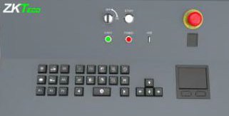
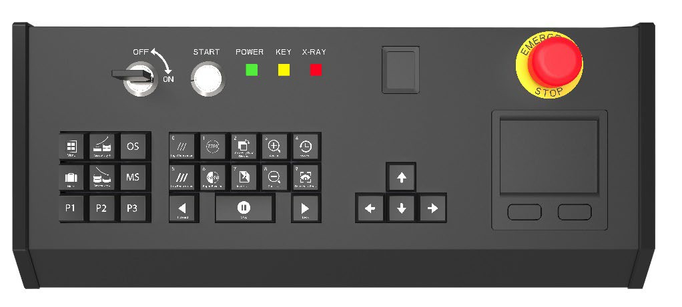

Special Keyboard

Figure 3-9 Special Keyboard

1 2 3 4 5 6

7 8

9 10 11
Figure 3-10 Special Keyboard

1- Keyboard outer cover | 7 - Key zone
2 - Key slot | 8 - Touch pad mouse
3 - Start button | 9 - Fingerprint reader USB interface
4 - Indicator light | 10 - Touch pad mouse USB interface
5 - Fingerprint reader | 11 –DB15 Control interface
6 - Emergency stop button

Description of Components and key functionalities

 | Key slot: The main switch is designed to power on the equipment after connecting to an external power supply. It is also used to prevent unauthorized persons from operating it.
 | Start button: Press the Start button to start the equipment operation and the green indicator light will glow indicating that the equipment has started.
 | Fingerprint reader: The fingerprint reader is used to login or add a new user. If the fingerprint is successfully verified, a green light will flicker. If the fingerprint verification failed, a red light will flicker.  The fingerprint reader includes a storage device that can store the fingerprint data of 65,535 users and each user can enroll up to 10 fingerprints. The User name can only be set to a number maximum of 6 digits i.e the User ID must be in the range of 1-65535.
 | Indicator light:  (i) X-Ray indicator light (red): When the security equipment starts X- Ray generation, the red light will glow; when the X-Ray scanning is completed, the red light will fade out.

 | (ii) Power indicator light (green): When the security equipment is powered on, the green light will glow; when the security equipment is powered off, it will fade out.
 | Emergency stop button: In case of emergencies, press this button immediately. The X-Ray generator and the conveyor of the equipment will stop working immediately. Since the emergency stop button is connected with interlocking devices, the X-Ray generator and the conveyor of the equipment will be powered on and put into normal use only after restoring all the interlocking devices and clicking the Start button. Turn the button clock-wise to release the button and press the Start button again to restore the equipment to normal status.
Key Controls (control operation, image processing, menu/functional shortcuts)

 | (i) Keys to control the conveyor: Click "Forward" or "Backward" to make the conveyor to operate in the direction set by the system. Click "Stop", and the conveyor will stop running.
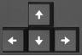 | (ii) Window navigation key: When the image in the scanning area is zoomed in or out, the bottom right corner will display a preview window automatically. Click any direction key to move the window. They can also be used as the navigation keys "up, down, enter, exit" in the system menu.
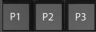 | (iii) Functional shortcuts: Please refer to "4.12.2 Keyboard" to set the shortcuts.
 | (iv) Menu: Click "Menu" to open the system menu.
 | (v) Marking key: Please refer to "4.10 TIP images".

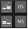 | (vi) Image processing function: Please refer "4.5 Image processing function" to set the display effects. Those keys are used to process the image and the image will be displayed as per the settings.


PC Keyboard and Mouse
The X-Ray Inspection system can not only operate with a special keyboard, but also operate with PC keyboard. 5030A and 5030C are the standard wireless button mouses which are supported by the equipment. You can use the mouse to navigate in the software interface. The ordinary keyboard can be used to perform the image processing operation. The shortcuts are given below:
PC keyboard shortcuts

Function keys (F1-F12)
F1 | P1 | F2 | P2 | F3 | P3
F4 | Forward | F5 | Stop | F6 | Backward
F7 | Image management | F8 | Pull front | F9 | Pull back
F10 | F1-F12 disable or enable | F11 | Zoom in | F12 | Zoom out
Alphabet keys
A | Black & White | B | Inversing image | Image Processing Function
C | Organic Material | D | Inorganic Material
H | Absorptivity+ | G | Absorptivity -
I | High Penetrate | J | low Penetrate
K | Perfect View | N | Dynamic Scan
M | Menu | R | Recover
P | Mark
Direction keys

↑ | Up | ↓ | Down | After zoom in, moves within the frame
← | Left | → | Right | After zoom in, moves within the frame
Numeric key
The numeric keys (0-9) performs only numeric function. |  |  | User ID and Passwords are numericals of maximum 8 digits.

Image Processing and Software Operation



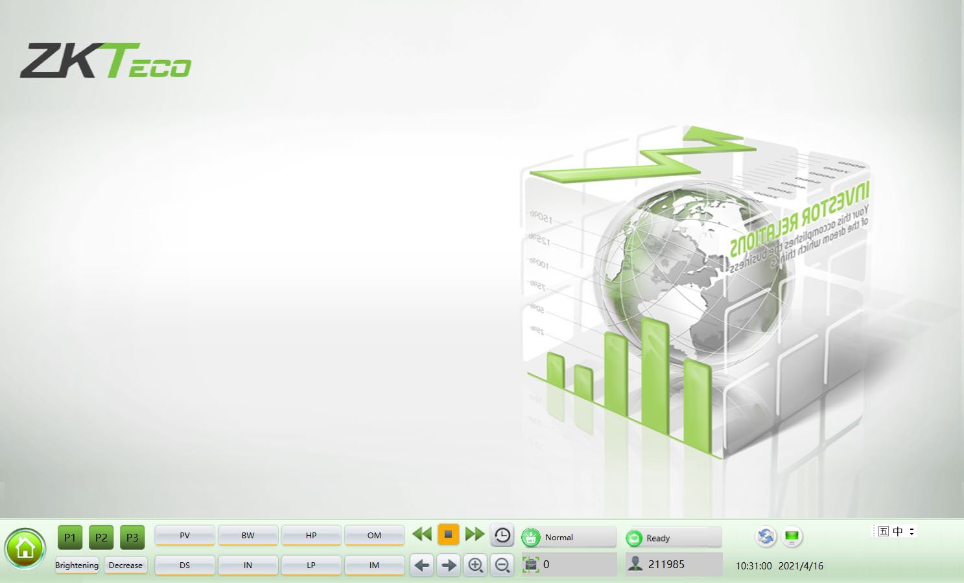
Main Interface
The blank area displays the scanning image.

Figure 4-1 Main Interface

System Software

① ② ③ ④

Figure 4-2 System Software Panel Introduction
① System main menu (Please refer "4.6 System Options")
② Image processing function
③ Operating function area

④ Information area


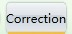



Information Area
Account information: After authenticated login to the device account, the information area will automatically display the current user name.
Parcel number counter: Displays the current user, total number of scan and total number of packages.
The date and time: Displays the date and time of the system.
Image correction: When the device is working for a long time, there would be slight changes in working of the X-Ray generator which results in poor image quality. In this

case, you need to click to restore the image quality.

Work mode: Scan mode , Training mode .

Device status: Normal state of the device shows .

Ready | The device boots and self-tests when powered on. If the self-test is successful, then the software displays "Ready"
Scanning | The equipment operates normally. X-Ray emission indicator will glow and the software interface displays "Scanning".
Error | When the equipment fails or cannot connect with other components, the software interface displays "Error"
Emergency stop button: The emergency stop button is used in hazardous situations. Once the button is triggered, the equipment will immediately disconnect the X-Ray generator and power supply hence protecting the people from injuries or other damages.

Ready |   Displays the normal working state .

Emergency | Displays (Emergency) if the emergency button is pressed .


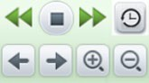






Operating Function Area

Figure 4-3 Operating function area

Restore the image: Click" ", after processing the image to restore the image color which has been set on the system.

Conveyor control: Press " " on the screen or tap the corresponding conveyor
control key on the Special Keyboard to accomplish the "Forward", "Stop", "Back" movements of the transmission belt, respectively.
Image pull front, pull back: During image interpretation, if the scanned image has

crossed the display, you can pull the image to front. Click icon or press the
direction buttons on the control board to drag the image, it allows the operator to view the previous images.

Image zoom in and out: Click and or press the zoom button to zoom in and zoom out the image. It could zoom in up to 64 times.
Combined Multi-processing Function keys: Through "4.12.2 Keyboard" in the combination of key settings, image processing functions and P1-P3 keys facilitate the image processing operations.

Figure 4-4 Combined multi-processing function keys


Image Processing Function

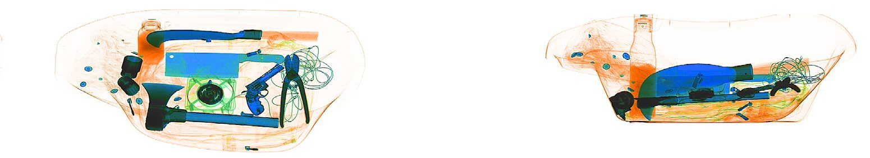
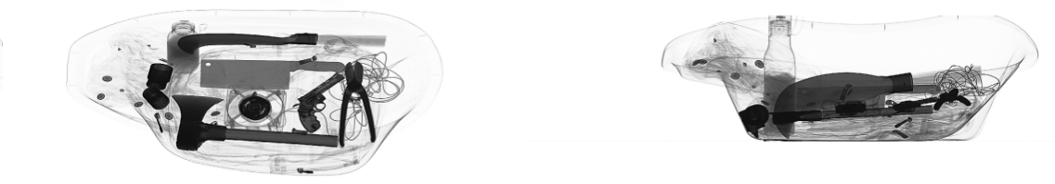
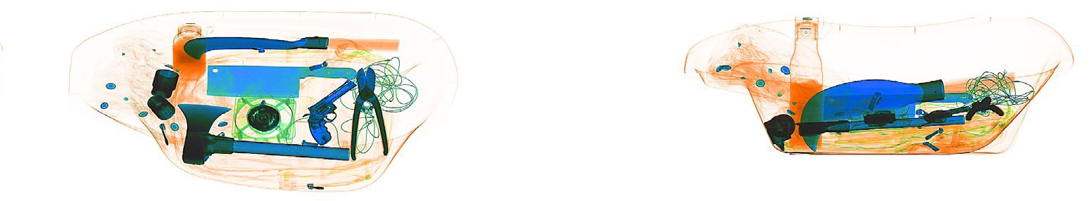
The following images are from the dual-view series security inspection system. The horizontal images are applicable to the general series security inspection system. The following images are real and they are scanned during inspection.

Horizontal image Vertical image

BW/CL (Black&White ⇔ Color)

Figure 4-5 Black & White Image

Figure 4-6 Color Image

To make the inspection efficient, different materials will be displayed in different colors. Inorganic materials will be displayed in blue, organic materials will be displayed in orange and the mixed materials will be displayed in green.

HP (High Penetrate)
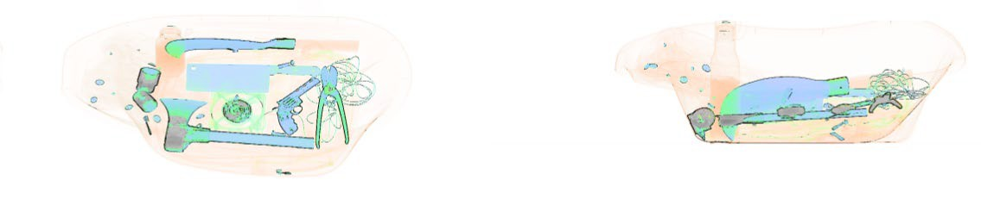
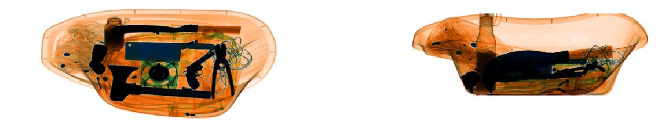
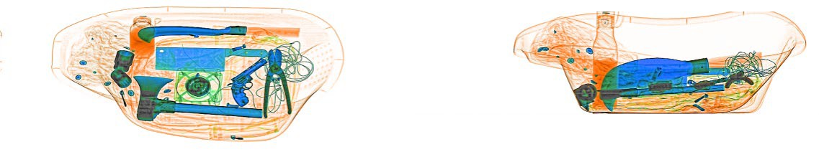
This feature improves the contrast of the dark areas.

Figure 4-7 High Penetrate Image

LP (Low Penetrate)
This feature improves the contrast of the light areas.

Figure 4-8 Low penetrate image

PV (Perfect View)
This function shows both the easy-penetrate items and hard-penetrate items at the same time. Even if the item is hidden between two metal boards, it can be displayed clearly.

Figure 4-9 Perfect View Image

OM (Organic Material)
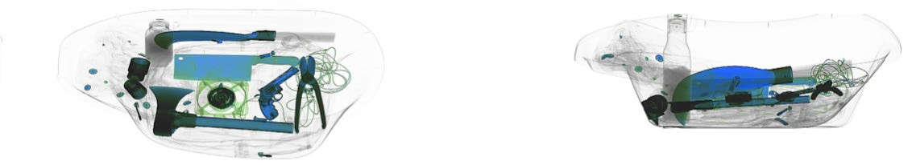
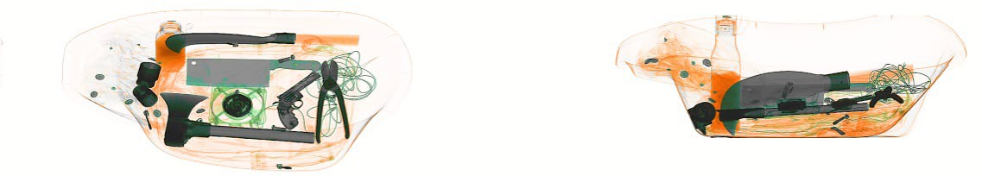
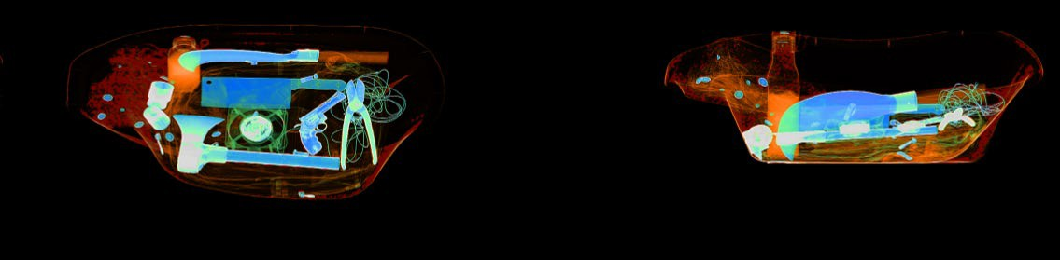
This feature displays the organic material as a B&W image.

Figure 4-10 Organic Material Image

IM (Inorganic Material)
This feature displays the inorganic material as a B&W image.

Figure 4-11 Inorganic Material Image

IN (Inversing)
Invert colors function is applicable to observe the condensed cable.

Figure 4-12 Inversing Image

Adjusting Brightness
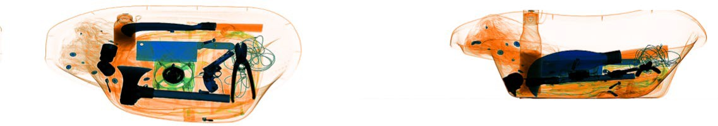
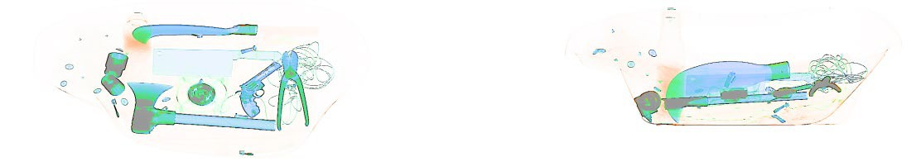
This feature helps to increase/decrease the brightness of the image.

Figure 4-13 Bright image

Figure 4-14 Dull image

DS (Dynamic Scan)
The images will be displayed dynamically using this function.

PS (Pseudo-color Display)
The single-energy equipment can be set to pseudo color display. The dual-energy equipment can be set to color display.
All the inspected objects are displayed in different color levels of the spectrogram and the color represents the actual X-Ray absorption degree of the object.

Suspicious Organics Enhancing Feature of Z789
The atomic number of explosives and drugs are within the range [7, 9]. The purpose of this function is to highlight the substances with suspicious organics to be bright red and the other substances be displayed in grey color. It’s helpful to view the suspicious explosives and drugs. Z789 can be enabled by pressing the "E" key on the special- purpose keyboard or wireless keyboard.


System Options


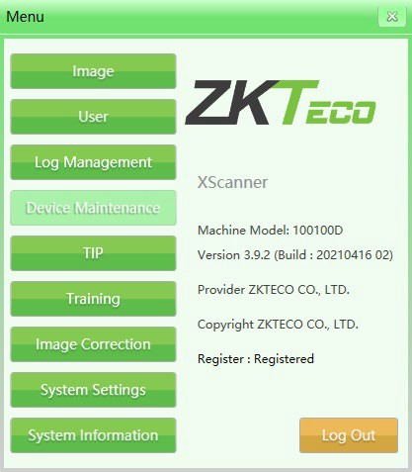
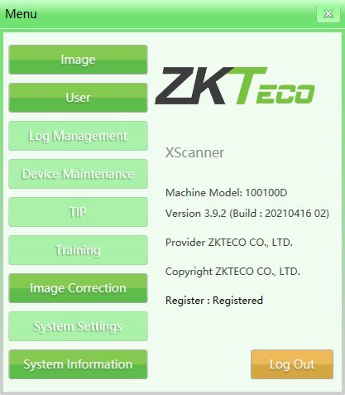
The system has two user groups, namely Administrator and Operator. The Administrator and operator have different authorities: The operator can only change the image settings and modify the password of the current user and the Administrator can modify all the settings except "Device Maintenance".

Figure 4-15 Administrator and Operator Menu

Image
The image option includes image preview and image setting.

Image Preview
Click the image name from the image list on the left of the interface and a thumbnail would be displayed on the right side of the interface.
All the images generated after scanning (originally scanned image) will be automatically saved in the hard drive of the scanning equipment. The preview interface will display the first 16 parcel images which are being saved currently. The storage order of the images will be chronological order of checking.

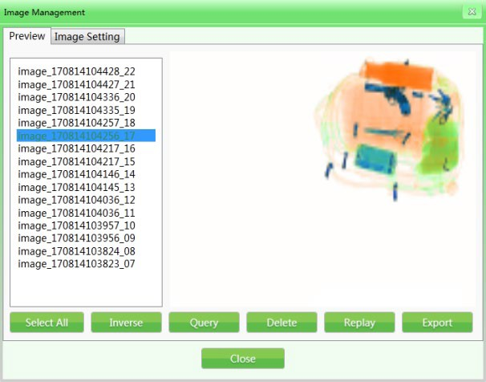
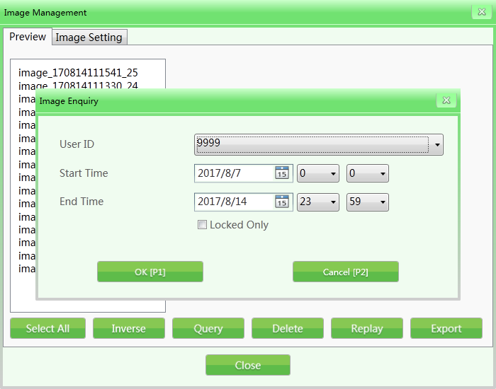
Figure 4-16 Image Preview

(Example: The naming format is image + parcel scanning time + serial No, for example, image_170814104217_16.)
- Image enquiry: During the image inspection process, you can check the older images through image enquiry.

Figure 4-17 Image Enquiry

- Delete: The authorized user group can delete the scanned parcel images of its own or subordinate.
- Replay: Select the Replay function and the selected images will be displayed on the main interface.

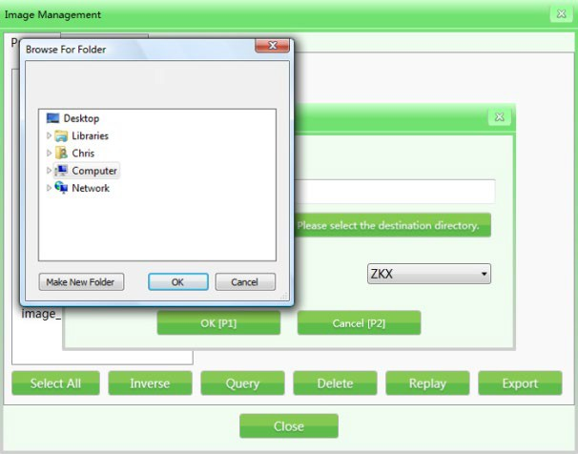
- Export: If you need to export the image files to process in other systems, then click "Export", and insert the storage devices (such as USB flash disk). Select the images and files to be exported (the format can be ZKX, BMP and JPG).

Figure 4-18 Image Export
Notes: If the images are exported in the format of BMP or JPG, then they are standard Window's image and can be viewed or reviewed by any image processing software.
If the images exported are in the format of ZKX, then they can only be displayed or previewed by the ZKXScanner software.

Image Setting
The image setting which is being used currently will be reflected on the display interface in real-time. The basic settings are configured for users before delivery and it’s not suggested to modify the settings.

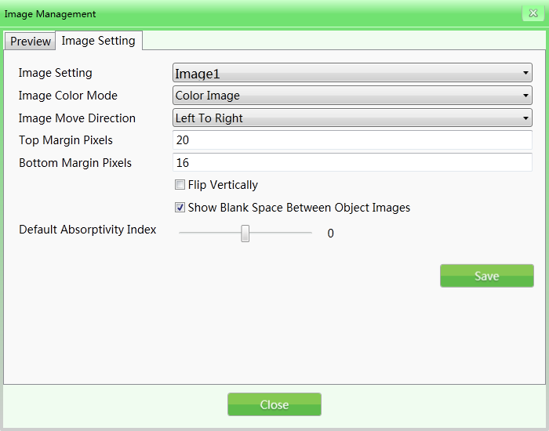
Figure 4-19 Image Settings

- Image setting: The image setting includes image 1 and image 2 options(for double- screen display). You can set the images separately which can be displayed on different screens. If the equipment is a single-screen display, you can only select the image 1 option.
- Image color mode: The Image color refers to the display color mode designated during the scanning process.

Modes:

(i) Black & White image | (v) Organic material
(ii) Color image | (vi) Suspicious organics enhancing Z7
(iii) Pseudo-color 1 | (vii) Suspicious organics enhancing Z8
(iv)Inorganic material | (viii) Suspicious organics enhancing Z9
For their image effects, refer "4.5 Image processing function".
- Image move direction: The scanned parcel image can be displayed from left to right or from right to left.
- Top/Bottom margin pixels: The setting range for the Top or Bottom margin pixels in the screen scanning area will differ for each equipment of different models. Bigger the value, larger the margin pixels area (white edge).

- Flip vertically: Vertically flips the scanned parcel images in the main interface.

- Show blank space between object images: Adds blank areas between the scanned parcel images so that operators can clearly identify the parcel images scanned before and after.
- Default absorptivity index: Absorptivity can be used to show the details of objects in different materials and thicknesses in the image. Variable absorptivity still keeps certain contrast beyond the absorptivity range. This function can brighten/darken the whole image (similar fine tuning of high/low penetration). The lower the absorptivity level, the brighter the image will be, so decrement effect will be effective in the opposite way. The levels of the system setting are 50, i.e., -25 to +25. Brightening corresponds to the "absorptivity-" and darkening corresponds to the "absorptivity+" on the keyboard.

User Management
By using this function, the administrator can add and manage operators, reset the operator passwords, etc by himself. The software is designed to support two-level authority by default, in which the authority of administrator is greater than that of the operators and operators can only change the information in their own accounts.
Note:

The user name shall not exceed 6 digits, i.e., 1-999999. The password shall not exceed 8 digits, i.e., 1-99999999. The default password for a new account is 123456.

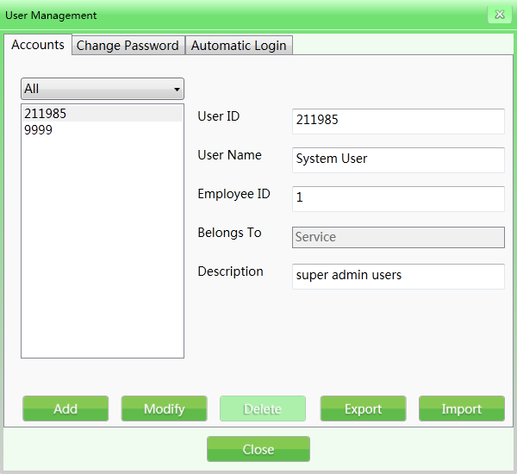
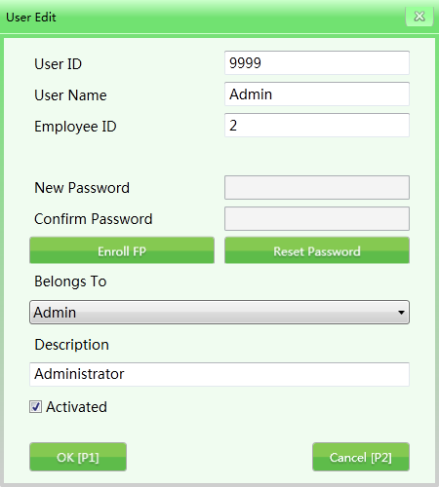
Account Setting

Figure 4-20 Accounts
Add: Click “Add” to create a new operator account. The User ID and password cannot exceed 8 digits. The fingerprint reader includes a storage device which can store the fingerprint data of 65535 users and each user can enroll up to 10 fingerprints. The user names to log in by fingerprint are within the range of 1-65535.

Figure 4-21 User editing interface

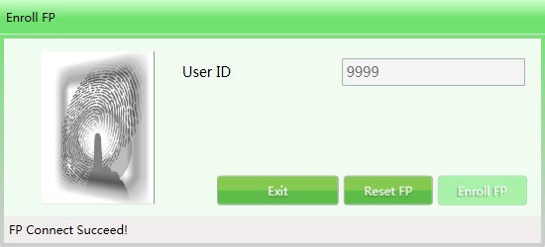
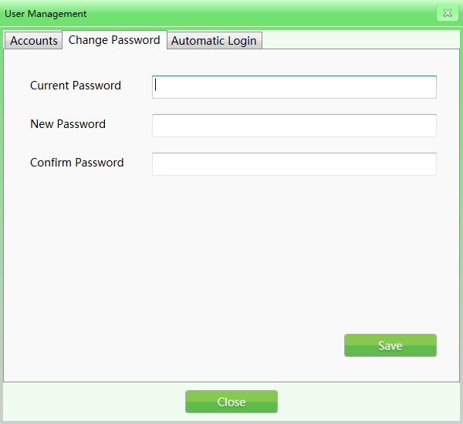
Figure 4-22 Fingerprint registration

- Modify: Click "Modify" to edit the personal data of the users.
- Delete: Click "Delete" to delete the user (operator) who will not use this equipment anymore.
- Import/Export: This function allows the administrator to import/export the account group information (only for ZKX Series, file type is XML).
Notice: Once the user is deleted, the data cannot be recovered. Please be careful while deleting users.

Change Password
If you need to modify the password, please enter the old password then type a new one.

Figure 4-23 Change Password

Automatic Login

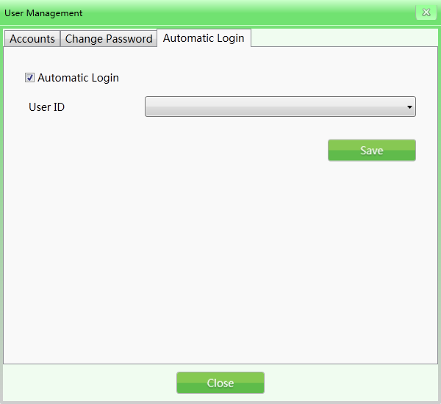
Select the Automatic login check box to automatically login a specific user.

Figure 4-24 Automatic Login

Log Management
This function enables the Administrator to get the statistical data and view the working status of the operators The Log management includes three log types namely: "Startup log", "Session log" and "X-Ray radiation log". The user can enquire the records with specific conditions.

Startup Log
Record running time of device: It could search by Week (in the year), Month (in the year), and Season (in the year). The statistic time indicates the start time of each period.
Export record: The users can select a single or several records to export. The data will be exported in CSV file format.

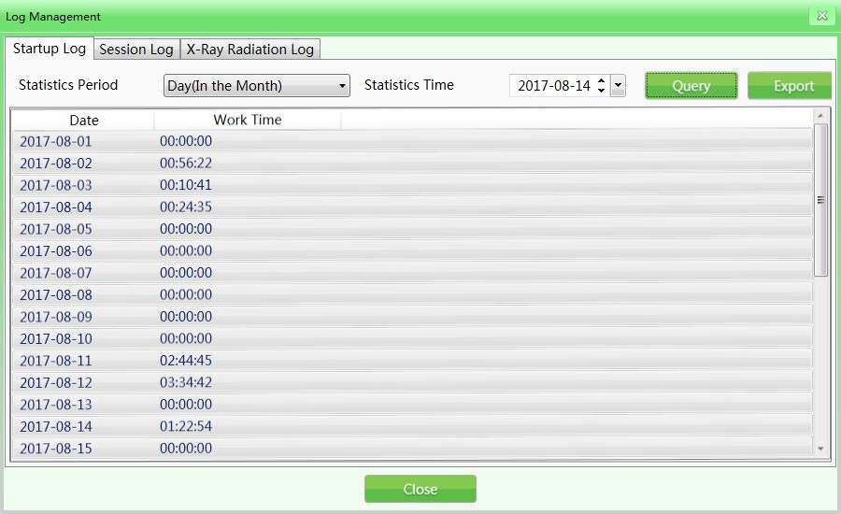
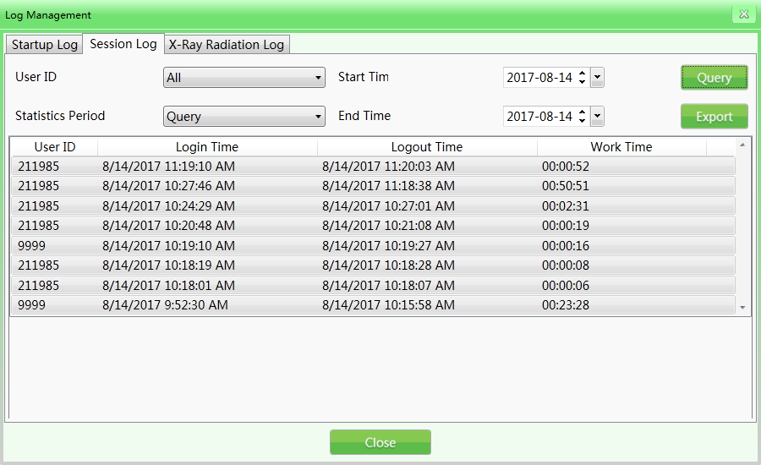
Figure 4-25 Startup Login

Session Log
Session log displays the working time of each operator. The system will record the start time and end time of each user's working time.
User ID: Select a specific user or select all users.
Statistics period: It is the same as running log. The log supports searching by Day, Week, Month and Year. (Example: 2017-08-14, select "All" in the User ID drop-down menu, set the start time and end time and click "Query" to get the results. The image is given below:

Figure 4-26 Session Login

X-Ray Radiation Log

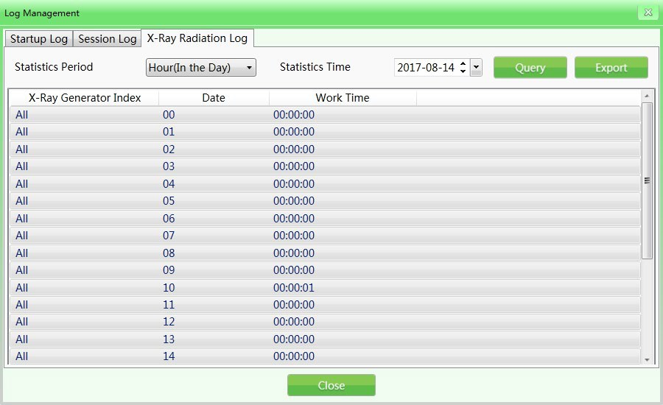
The log displays the usage time of X-Ray generator within the specified time range that helps the administrator to track the working status of the equipment. The records can be exported in the same way as explained above.

Figure 4-27 X-Ray Radiation Login

TIP (Threat Image Projection)
Based on the relevant parameters set by the administrator, the system can automatically inset the luggage image containing dangerous articles into the images of scanned articles or inset the dangerous articles of different kinds into the actual images of inspected articles. Like normal images, TIP images will be saved automatically by the system. From the statistical reports of the system, the administrator can know the correct identification and the number of exclusions of each operator on the scanned dangerous articles. And thus the administrator can get to know the image reading level and
efficiency of each operator. (After checking " " to initiate this function, it can operate under image scanning mode and training mode.)

TIP purposes:

- To enhance the vigilance of operators and to prevent exclusion of dangerous materials.

- Image reading ability of the security inspectors is one of the skill assessments.

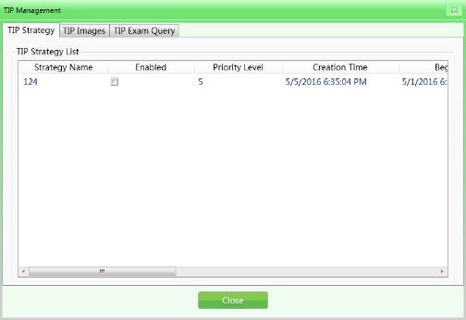
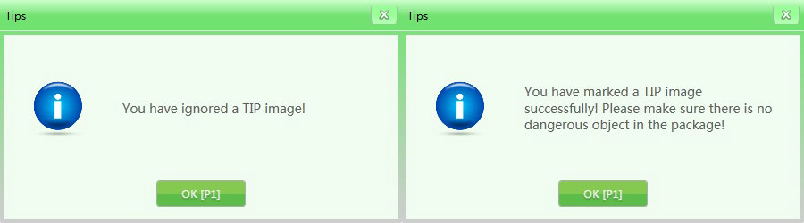
TIP operation procedure:

Figure 4-28 TIP Operation

Log in to the administrator account, set the TIP strategies and set the system in default TIP assessment state. When the operator operates the equipment and finds any dangerous articles, the operator must press the "Stop" button of the conveyor first and press the "Mark" button on the special-purpose keyboard or the "P" button on the common keyboard. Then the system will show successful marking and the operation record will show the successful identification by the operator. If the operator fails to inspect the inserted dangerous articles, it will show "You have ignored a TIP image" immediately after passing the dangerous articles and this mistake will be recorded. TIP system interface is shown in the following figure:

Figure 4-29 TIP Notice

TIP Strategy
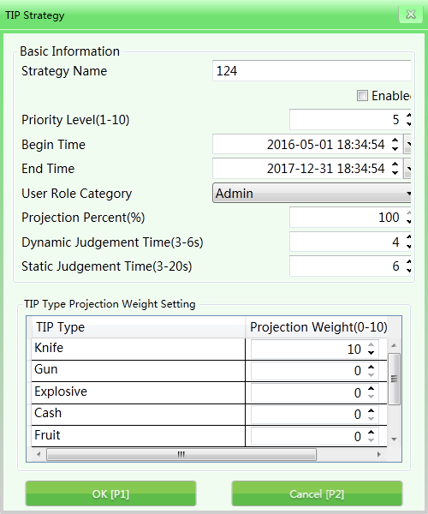
It can set the TIP basic information and the projection percent.
Basic information set in TIP: You can set the strategy name, priority level (1-10), start time, end time, user role category, projection percent, dynamic judgement time and static judgement time as shown in the following figure:

Figure 4-30 TIP Strategy
Strategy name: Set the strategy name according to the training records and query needs.
Enable: It means the TIP mode can be enabled by selecting the check box. In addition, the following settings can only be initiated when the TIP is in "ON" state.
Priority level: The administrator will set the priority levels (1-10 levels and 1st level is the lowest level) for the newly built assessment items. Items with higher levels will be used as a priority in assessment, if the priority conditions are not satisfied, the system will initiate the low priority items.
User role category: Select the operators or administrators to receive the TIP training based on different User role categories.

Projection percent: It means the percentage to insert the dangerous articles in the training image collection.
Dynamic judgement time: When the article images are moving, and the TIP dangerous articles are inserted, then the time period from appearance to disappearance of TIP dangerous articles is defined as the dynamic judgment time (determines whether the articles are dangerous within the time limit).
Static judgement time: When the article images are still (not moving), and the TIP dangerous articles are inserted, then the time period from appearance to the disappearance of TIP dangerous articles is defined as the static judgement time.
Projection weight: It mainly allocates the weight on different TIP types during use. The TIP types mainly include: "knife", "gun", "explosives", "cash", "fruit" and etc.

TIP Images
TIP image refers to the image gallery which will list the images of dangerous articles to be inserted and opens the image in the corresponding list to preview the image.
Export: With authorization, you can export the TIP images in the list as typical images to the selected files (Recommended to export in ZKX format).
Import: With authorization, you can import the typical images as TIP images (only in the format of ZKX).
Delete: With authorization, select the corresponding sample images and click "Delete" to delete the corresponding TIP images.

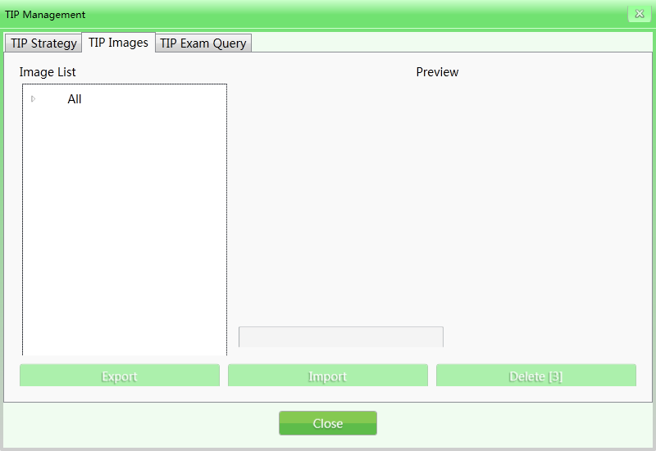
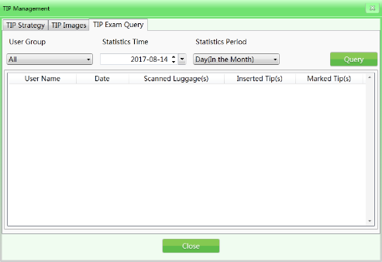
Figure 4-31 TIP Images

TIP Exam Query
This feature allows you to query about the TIP inserting process, User ID, Date, Quantity of luggage scanned, No. of exclusions, number of markings. You can export those information by pressing the "Export" button. The TIP report generated in this login will be shown in the next login.

Figure 4-32 TIP Exam Query


Training

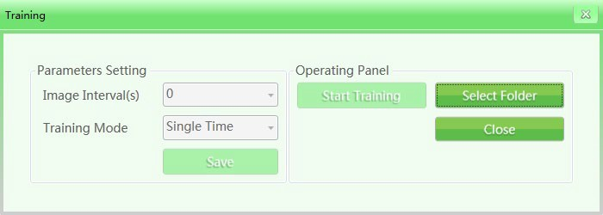
After initiating the training function, the administrator can train the operators on image reading. The training function is used to train and assess the operators’ ability to identify the dangerous and prohibited articles. The training doesn’t need to start up the Conveyor belt and X-Ray generator, but to simulate the article scanning process and display a series of scanned images saved by the administrator in Industrial Personal Computer (IPC) disk on the screen. The "Training" interface has "Parameter Setting" on the left and "Operation Panel" on the right.

Parameters Setting
Click "Training" on the main menu to open the training interface as shown below:

Figure 4-33 Training Set
Image intervals: Set the display time interval between the consecutive images. Select the "Image interval" and set the time interval, such as "1", "2" or other time intervals as required by the administrator. The setting range is between 1-120 seconds.
Training mode: Click the drop-down list to view the available training modes. The options are: "Single time", "Sequential circulation", "Random circulation" and other modes. The operator can select the "Training mode" based on specific needs.

Operation Panel
Click the "Select folder" button to manually select an image gallery used in training on storage devices.


Notes: If the customer initiates the TIP function, then all the operation results in training demonstration will be recorded in the system. The system will get the statistical data on a TIP quantity and the TIP data of all users. The administrator can check the relevant data in TIP exam query.

Training Procedure
Step 1: Select the folder to choose the scanned parcel files required in training.
Step 2: Set the parameters (the save button is used to save the settings and backups).
Step 3: Click “Start” to start the training. The training box can be deleted but it will still be shown in the menu bar (the icon means the training is going on).
Step 4: Click any operational key of the conveyor (in training mode, clicking any operational key of the conveyor will not make the conveyor to move.) or image front- pulling key, the interface center will show the training images when simulating the operation of machine based on the parameter setting.
Step 5: When finding suspicious articles, press "Stop" button of the conveyor and the "Mark" button on the special-purpose keyboard to mark the image.
Step 6: If you want to finish the training, click the “Pause” button of the conveyor to stop the moving image and then click the menu or right-click the mouse to select "finish" to finish the training.

System Settings
This function is accessible by the administrator, including: intelligent identification, keyboard settings, counter settings and so on.

Intelligent Identification
You can set the "High density alert" and "Drugs and explosives inspection" in the "intelligent identification" interface; the initiate mode and sensitivity can be set
separately (when checking "" to switch to initiate mode respectively, the alert box of "High density alert" is red, the alert box of "Drugs and explosives inspection" is pink and

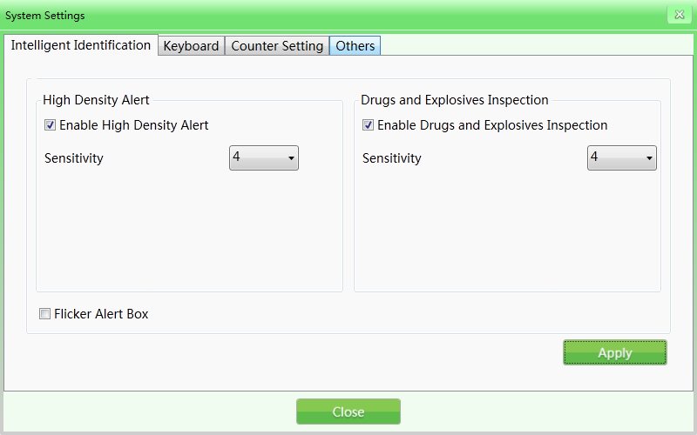
the sensitivity can be further set as 1-5), and 5 is the highest sensitivity; If the Flicker Alert box is selected, then alarm will be initiated.

Figure 4-34 Intelligent Identification

Keyboard

Functional key(shortcuts): When you need to set the combined processing keys, click the "Keyboard" button and the system will pop out the following interface. Then select the corresponding combined image processing function from the drop-down list based on the specific needs.

Shortcut keys options

Color + perfect view | Black & White + super enhancing
Color + inversing | Black & White + inversing
Color + high penetration | Black & White + high penetration
Color + low penetration | Black & White + low penetration
Switch between Black & White and color | Restore

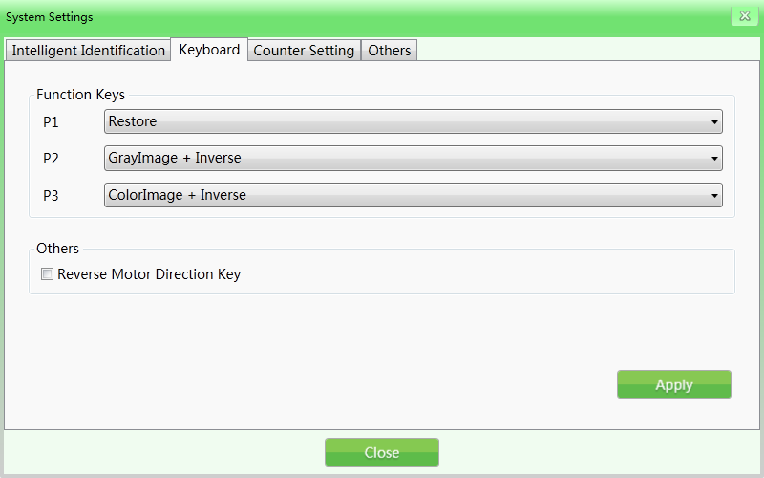

Figure 4-35 Keyboard
Reverse Motor Direction key: The default setting of the equipment is for the conveyor to run in the forward direction (the starting position is at the entrance and the movement towards "exit" is the forward direction). The direction of the conveyor can be reversed if required.

Counter Setting
If the operators need to know and record the quantity of the inspected luggage, they can check the "Counting of inspected articles" on the system status panel or in the "Counter setting" interface.
Total package counter: It means the total number of the inspected articles since the equipment has been put into use. This value cannot be reset.
Temporary package counter: It means the number of the inspected articles after this user logs into the system this time.
Notes: The selection will immediately effect in the parcel counting in the main interface

.

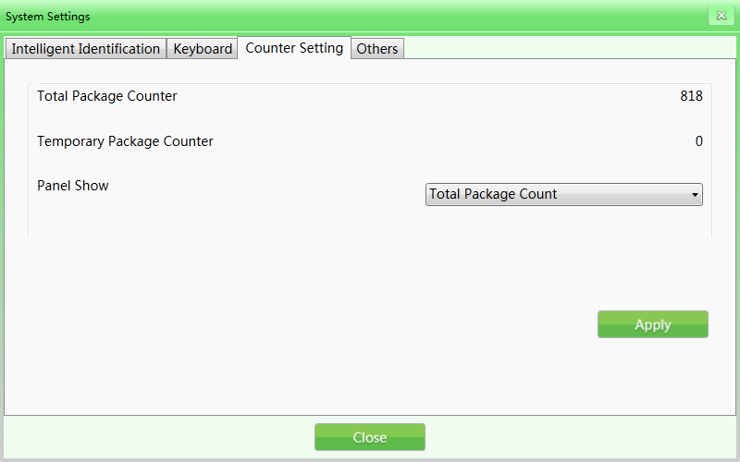
Figure 4-36 Counter Setting

Others
Date: When you need to set the time and date, click the "Date" button to set the local time on the equipment.
Time zone: You can also choose this option to change the current time.
Summer time: If the selected time zone has Daylight Saving time, it can be selected or this option will be disabled.
Energy Saving Mode: When the entry is sensed, the device will be turned on and the machine will automatically turn on the motor to complete the scanning process automatically. After scanning, the motor will automatically stop running.


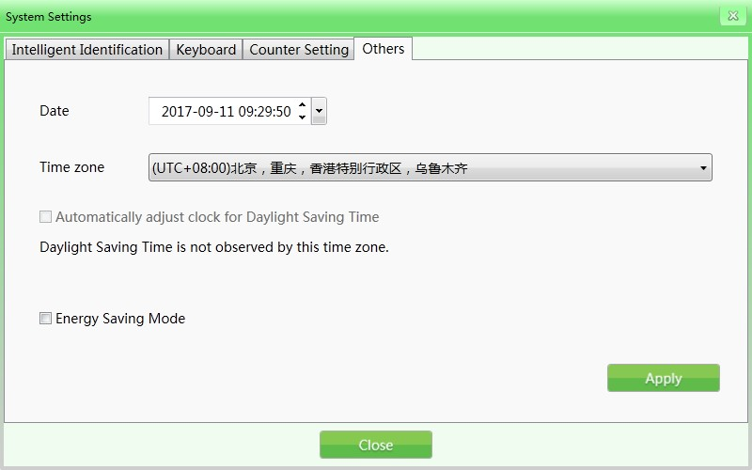
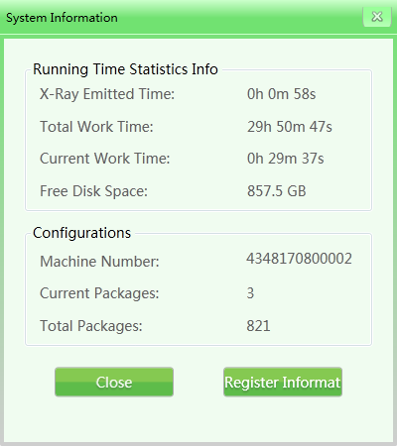
Figure 4-37 Other

System Information
It includes running time statistics information and configuration.

Figure 4-38 System information


Log out and Shutdown
Log out: This option can be used to change the current user.
Shutdown: This function shuts down the industrial motherboard after the key is turned to off position.
Notes: Turn the key to "off" position and wait until the green light goes off, and the system will finally shut down.

Maintenance Instructions



The X-Ray security inspection system is a sophisticated mechanical and electrical product. It is necessary to maintain the equipment on a daily basis apart from learning the technical performance, software management and operational procedure of the equipment. This chapter illustrates the tips and procedures for daily maintenance.

Installation Environment

- The equipment should be installed in a ventilated, dustless and dry environment and avoid high temperature, moisture and direct sunlight.

- Clean the dust on the equipment by brush and vacuum before maintenance.

- If the components or connectors are loose, tighten them immediately.

- Do not let any material or liquid into the equipment during maintenance in order to avoid electric leakage or accidents.

- If the components get rusty or damaged, please contact our technician without delay and do not dismantle the equipment by yourself.

Daily Cleaning
Note: Do not power on the equipment during cleaning.

Outer Surface of the Equipment
After operating for a long time, the outer surface of the equipment, control console, display screen and other parts will be covered with all kinds of dust, stain and other dirt. To guarantee the normal function of the equipment, the outer surface of the following must be cleaned regularly.

- Wipe the outer surface of the equipment with a wet towel.

- The surface of sideboard and top board of the equipment.

- The guard boards on both sides of the conveyor and the cover board under the conveyor, etc.

- The surface and edges of the belt.

- Ventilation port.

- The surface and other places of the control console.

Interior of the Equipment
The interior of the equipment is of utmost importance since it includes the Industrial Personal Computer (IPC), electrical control panel, air switch, detection box and other important parts. When cleaning the interior on a daily basis, it’s suggested to remove the stubborn dust by brush or vacuum. It is recommended to clean the following parts on a regular-basis to ensure smooth functioning of the equipment.

- IPC part.

- Electrical control panel part (please take off the installation case and the cover) and the electrical device terminal.

- Air switch part.

- For X-Ray generator and detection box, clean the dust on the surface, do not unscrew the retaining screw.

- Cover of the cooling fan and dust-proof fan.

Display, Slot of Photoelectric Sensor and Control Console

- During the daily usage of the equipment, the surface of the display and fingerprint reader will be covered by dust which will influence the operators when reading images and identifying articles. The display screen (in off state) can be cleaned by a wet towel with a detergent.


- When the slot of the photoelectric sensor is blocked or jammed, the radiation source will always be in radiation state. If the radiation light is always bright but there’s no image on the screen, then the slot of the photoelectric sensor may be jammed by dust or dirt. In this circumstance, you can use a brush to clean the slot and then vacuum the dust.

- Open the rear of the control console by triangle keys and clean the stubborn dust inside by a brush or vacuum.

Regular Inspections
If the equipment does not function well because of the following devices or installations, please contact the technician for consultation and repair.

Inspection of Photoelectric Sensor
Start the equipment and place a parcel on the conveyor for inspection. If images of the articles can be normally displayed on the screen, then the photoelectric sensor functions well.
If images of the articles cannot be normally displayed on the screen or the images are always moving and gliding across the screen, then please clean the slot and surface of the photoelectric sensor. Conduct inspection again to check whether it performs well.
If the images still cannot be displayed, please contact the technician for consultation and repair.

Inspection of Conveyor
After working for a long time, the conveyor belt will be unevenly loaded since the weight and position of articles are not uniform, which may cause the conveyor belt to deviate from the center position of the passage. In this case, please contact the technician for consultation and repair.


Inspection of Lead Shield at the Entrance and Exit of the Passage
If the interval spaces of the lead shield are large or it falls off and gets damaged, please contact the technician for consultation and repair.

Inspection of X-Ray Light Indicator and Power Indicator Light
During the operation of the equipment, if the X-Ray indicator light (red) or power indicator light cannot light up normally, please contact the technician for consultation and repair.

Inspection of Emergency Stop Button
The emergency stop buttons at the entrance and exit of the equipment and on the special-purpose keyboard are the critical safety buttons. When the equipment is inspecting the articles normally, and if the emergency stop button is pressed, the conveyor stops running immediately and X-Ray indicator light goes out, it indicates that the emergency stop button functions well. Later, restore the emergency stop button and press the start button, and the screen displays "normal", then the emergency stop button returns to normal state. If there are abnormalities in the functioning of the emergency stop button, please contact the technician for consultation and repair.

Storage Conditions and Notice

- If the equipment needs to be dismantled before delivery, perform the reverse installation process.

- The system should be stored in a clean and dry place, high-temperature or moist environment may cause damage to the system parts. If the equipment is out of use for a long time, it should be stored in the original packaging box.


- Equipment that needs to be stored for a long time should be packaged and well stored in a clean, dry and well-ventilated warehouse where there should be no corrosive gas around and the relative humidity should not be more than 80%.

- According to the regulations of measures for the Management of Security Permission of Radioisotope and Ray Devices issued by the People's Republic of China, the X-Ray radiation device in this product is Type III ray device. In case of any issue, the customers are suggested to report to the local competent environmental department.

- When the equipment needs to be discarded, please consult the relevant professionals or the local competent environmental departments for handling methods.

Troubleshooting
This section introduces the failures that may occur, causes and troubleshooting methods. If there are issues that cannot be solved, please contact our professional technician for consultation and repair.
It is advisable to use the components of our company for maintenance. If any failure or damage occurs due to unauthorized maintenance or unauthorized components, we will not be responsible.

Failure 1: The equipment did not boot normally after pressing the Start button.
If the equipment did not boot normally, check whether the power plug is plugged-in properly or not. Also check if the power supply is normal (200V to 240V). If the voltage supply is low or abnormal, repair the power supply unit or report to the relevant department to restore the normal power supply.

- If the power supply voltage is normal, but the machine still did not boot, then check the connection terminal 1 and 3 to see if the voltage between the two terminals is 200V-240V.

- If it’s not normal, then check the air switch on the equipment to see whether it is disconnected or not. Check the fuse whether it is disconnected or not. If the fuse is disconnected, then replace it.

- If the connection in the control line socket (DB15) on the special-purpose keyboard loosens, please re-plug the control line and check the equipment to check whether it can boot normally.

Failure 2: The conveyor belt is not moving

- If it happens, check whether one of the "emergency stop buttons" is pressed (emergency stop button on the device and console respectively); if so, rotate the button clockwise and release the button and then press the "Start button" to start the conveyor belt.

- If the conveyor belt still did not run and displays "emergency stop is triggered", then check the two "micro-switches" on the equipment. Normally, when the two "sideboards" on the equipment are tightened, the "micro-switches" will be triggered. If the "micro-switch" is not triggered due to loosening of any one of the "sideboards", it will also lead to the display message "emergency stop is triggered". Tighten the sideboard and then press the "Start button" to run the conveyor belt.

- If the screen displays "emergency stop is normal", check the "over-current protector" DZ108-20 of the conveyor whether it trips (means over-current supplied to the motor cylinder and the trip is caused by over-weight of parcels). If it does, restore it manually (press the white button on the DZ108-20) and the conveyor must run normally (For AC motor cylinder).

Failure 3: The screen displays "System self-inspection error"

- Situation 1: The system displays "Collector connection error".

This is usually caused by the failure of power supply or transmission lines on the "transmission board" (inside a small metal box beside the "L-shaped shelf"). Check the power plug on the "transmission board" to see whether it is loosened or poorly contacted, and then re-plug the power plug. Check the plug of the transmission line to see whether it functions well, re-plug this cable plug and the cable on the IPC board.

- Situation 2: The system displays "Failure to open control panel communication".

This is usually caused by a failure of the data transmission line between the control panel and the industrial motherboard. Check the data line plug (DB9 plug) of COM1 port on the industrial motherboard and the data line plug (white plug of line 3) of J3 port on the control panel to see whether they are loosened or poorly contacted, if so, re-plug the data line plugs on the two ends.

Failure 4: Keys on the special-purpose keyboard does not work normally
If the equipment boots normally by the key switch and the start button on the special- purpose keyboard, but the motor key or image processing key did not work, then the failure is caused by the data line communication on the COM2 port. Check the data line plug (DB9 plug) on the COM2 port of the industrial motherboard.

Failure 5: The X-Ray Generator does not radiate normally
If the Conveyor runs normally but the ray did not radiate normally and the screen did not display images, please check the ON/OFF, XRAY_ON and POWER on the X-Ray Controller to see whether the indicators work normally (During inspection, press the micro-switch and press the Start button to recover the emergency stop state). Then press the emergency stop button and check whether the INTERFACE and POWER plug connection is loosened. If so, please re-plug the control line and check whether the equipment boots normally.

Failure 6: Power failure
First disconnect the power supply line, then check the air switch for tripping. If the air switch is tripped, please set it again. You have to wait for one minute, reconnect the power supply line, and then reboot the security device as usual.
At this point the windows system starts to repair or it starts normally.
If the system starts to repair, connect an external PC keyboard and click Normal Start.



ZKTeco Industrial Park, No. 32, Industrial Road, Tangxia Town, Dongguan, China.
Phone : +86 769 - 82109991
Fax
: +86 755 - 89602394
www.zkteco.com

Copyright © 2021 ZKTECO CO., LTD. All Rights Reserved.

