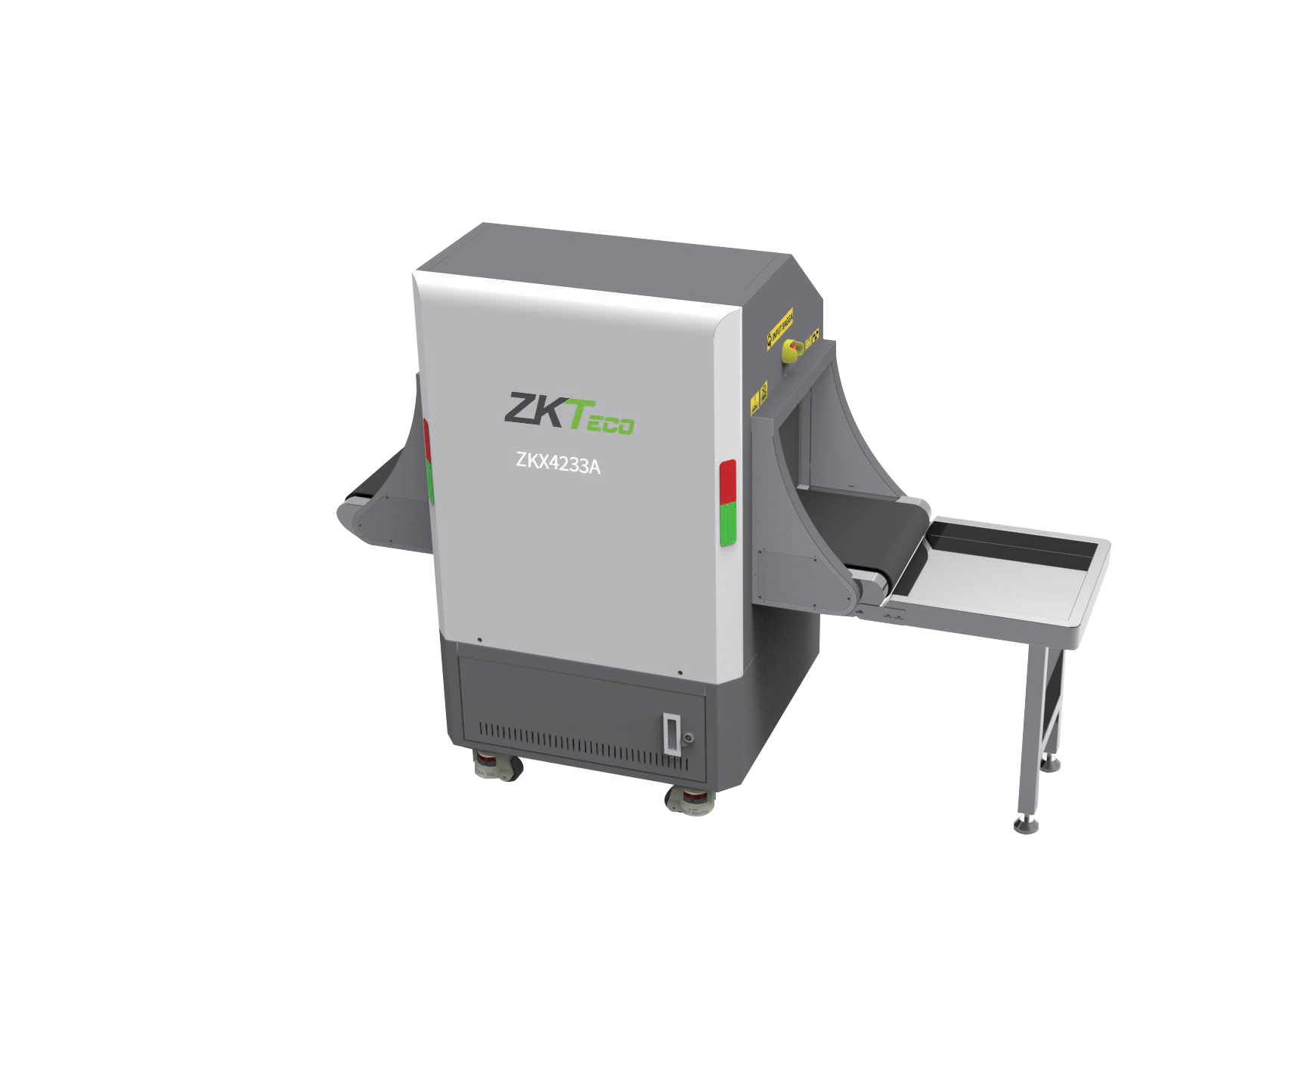
ZKX4233A X-ray inspection system increases the operator’s ability to identify potential threats; the device is designed to scan briefcases, carry-on baggage, small cargo parcels.
Single Energy X-ray Inspection System

ZKX4233A tunnel opening is as large as 420 mm by 330 mm, Benefit from the desktop and compact design, with a foldable keyboard and touch screen, small footprint allows for easy relocation and installa- tion, could be placed in bank, government offices, hotel and other occasions.

ZKX4233A uses reliable high quality hardware. With the superb image algorithm, ZKX4233A could offer clear scanning images, which allows operators to identify potential threat items visually.

Highlights



Costs-effective Compact footprint Pseudo-color
scanning image
Desktop design
21.5-inch Touch Screen




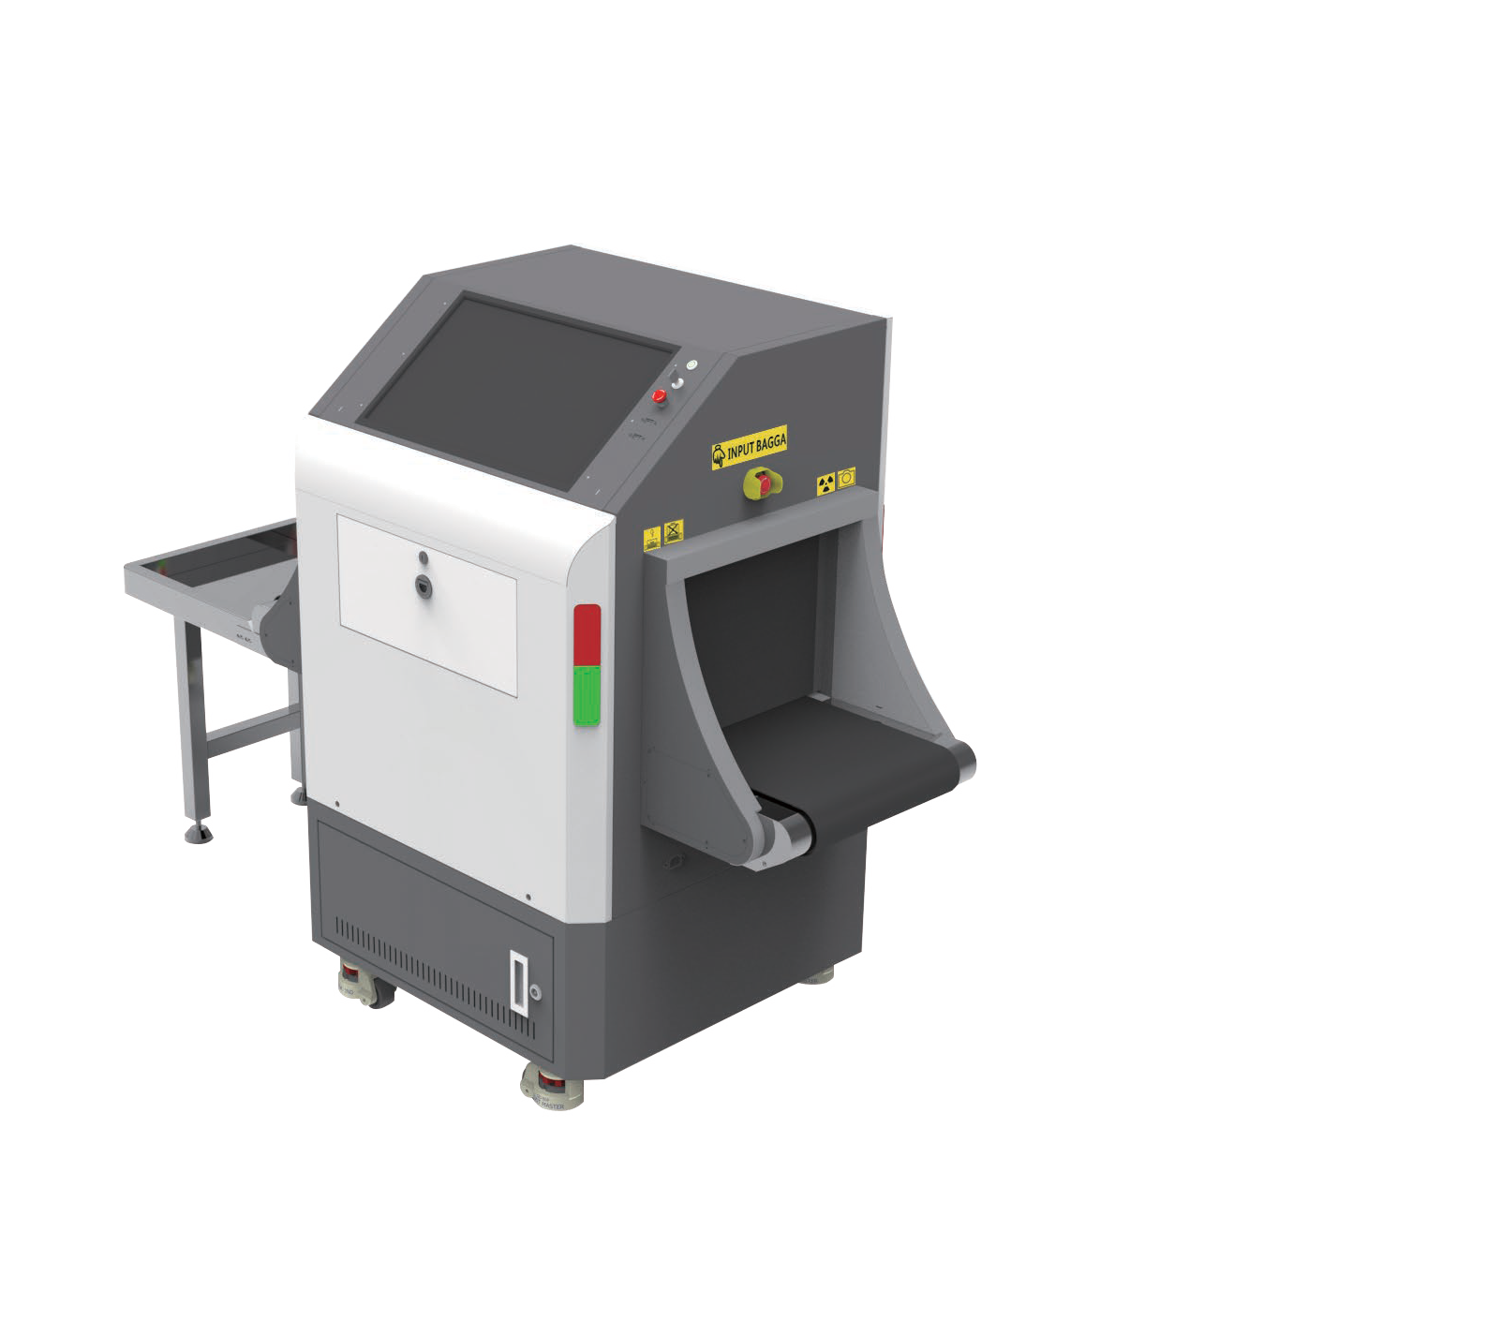

Energy Saving Mode
ZKX4233A
Introduction
Bidirection scan
Foldable Keyboard
High quality and clear images

Specifications

Model | ZKX4233A
Tunnel Size (W*H) | 420*330(mm)
Speed | 0.20 m/s
Height of Transmission Belt | 650mm
Load on Conveyor | 180kg (evenly distributed)
Wire Resolution | 36 AWG
Space Definition | Horizontal Φ1.0mm \ Vertical Φ1.0mm
Penetration | 8 mm Steel board
Monitor | 21.5 inch touch screen
System Function | High density alarm, TIP, Luggage counter, System running timer, X-ray emitting timer, System  maintenance, Training, 64 times continuous zoom in
Film Safety | ASA/ISO1600 standard of film safety
X-ray System

Tube Voltage | 80 KV
Tube Current | 0.5 mA
Cooling | Seal oil cooling / 100%
Radiation Leak Dosage | ≤0.3µ Gy/h (5cm from the shell)
Installation Specification Size (L*W*H) | 1385*755*1294 (mm)
Power Consumption | ≤500W
Noise | ≤55dB

Dimensions (mm)


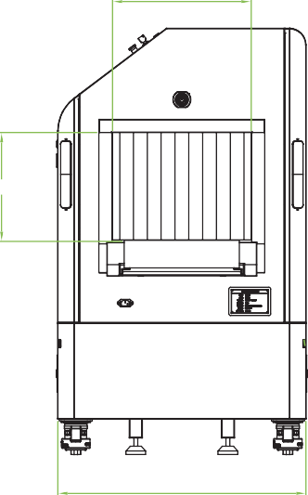
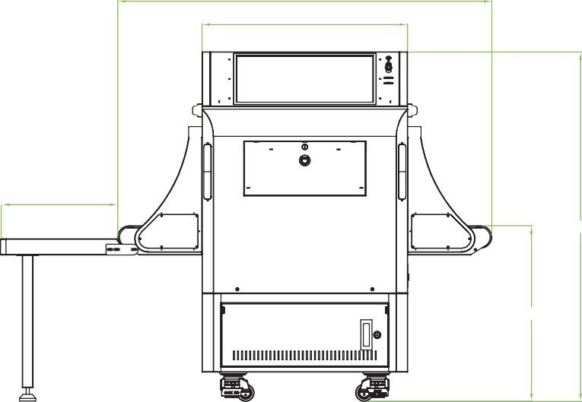
420
1385
761
429
1294
650

330

755

ZKTECO CO.,LTD. www.zkteco.com E-mail: sales@zkteco.com

V1.2 08/04/2023

Copyright © 2023 ZKTECO CO., LTD. All rights reserved.

