Installation Guide
ZKX6550
Micro Dose X-ray Security Inspection Device

Version: 1.2 Date: June, 2018

1 Unpacking

① Open the side panel with the triangle key.
Notice: You have to lift the side panel up and then remove it because there are two positioning nails connecting the side panel and the device.
② Loose and take out the four internal hexagon bolts.
③ Using a wrench, lower the four support leg under the device clockwise to raise the device, and then pull out the two support bars under the device. Twist the four foot cups counterclockwise to raise it until the wheels touches ground.
④ Move the equipment to where you want to install, close two sides(When closing, pay attention to the positioning nails at the bottom). Finally, twist the foot cups clockwise to lower it and ensure that the device is ﬁxed well and then locks the nut of foot cups.

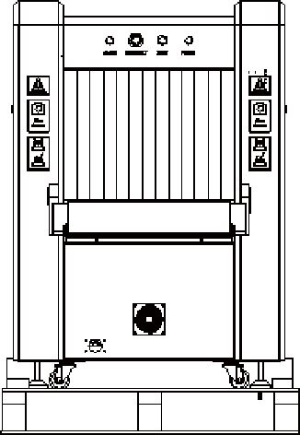
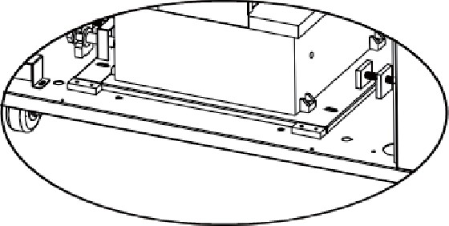
① ②
③

Internal Hexagon Bolts

Positioning Nails

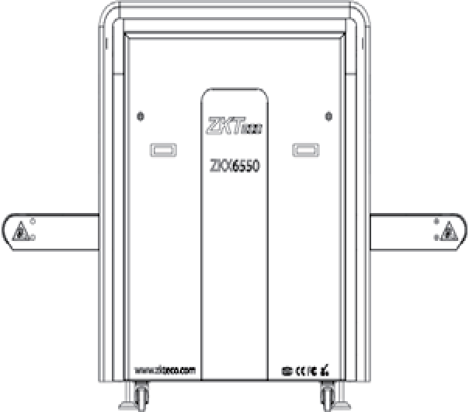
④

2 Assemble shelf

① Use 8 M6 X 20 Allen screws to connect the H shape trusses to the tray.
② Use 8 M6 X 20 Allen screws to connect the shelf and the device.
③ Put the roller on the shelf holder.
④ Adjust the height of the shelf foot-cup according to the height of the device.


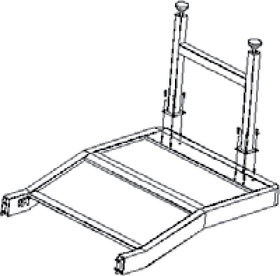
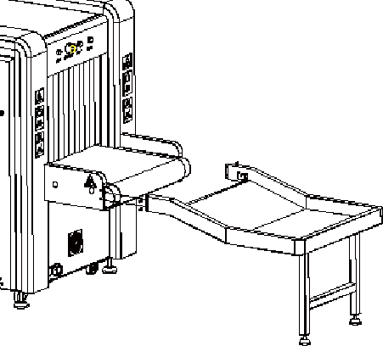
①
②


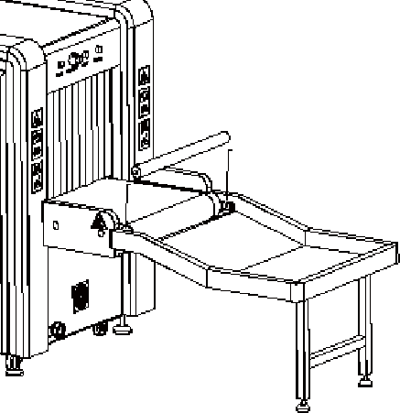

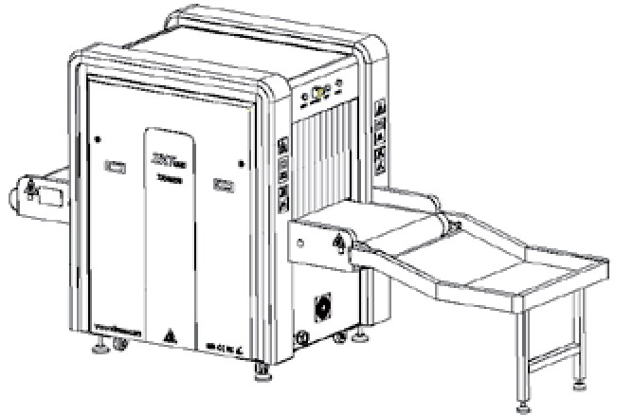
③
④
Adjust the height of the foot-cup

3 Wiring

① Open the back door of the console with the triangle key, unscrew the thin metal round nut at the front end of the bellows, and ﬁx the bellows with the thin metal round nut to console.
② Connect the power cables, VGA cable, DB15 cable, and USB cable in the bellows to its interfaces in console. Re-lock the back door with the triangle key.


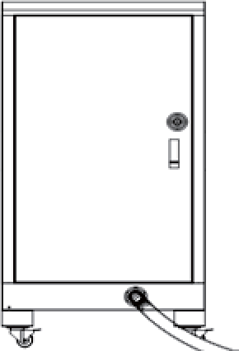
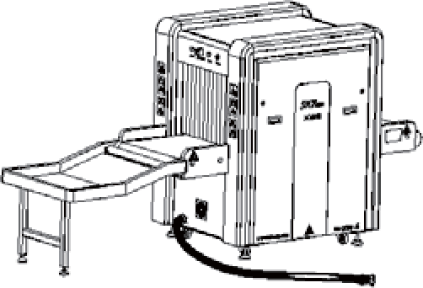
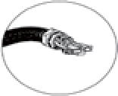
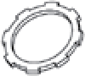
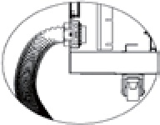
①
The thin metal round nut

②
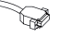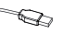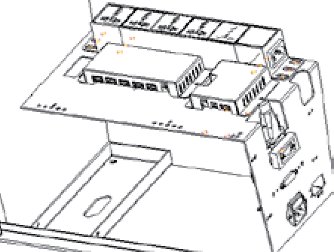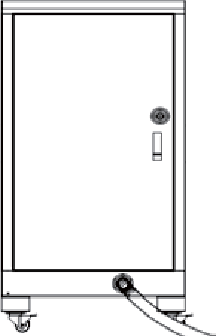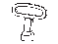
USB
Power VGA DB15

4 Boot
① Connect the power cord to the main power supply.
② After connecting the wires correctly and properly, you can reverse the key switch to "ON", then press the start button beside it and wait for the device to start.
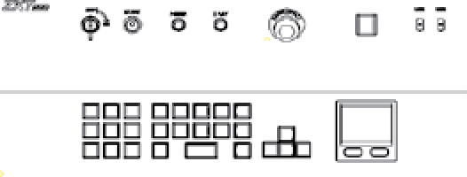
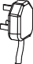
③ After powering, the software logins automatically as an administrator by default. The initial login details for administrator; User name: 9999 Password: 123456. We recommend to change the password after initial login.


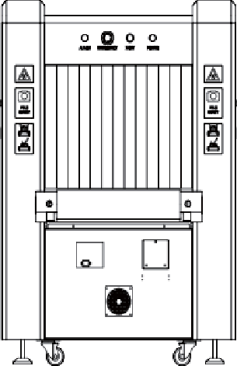

①
②


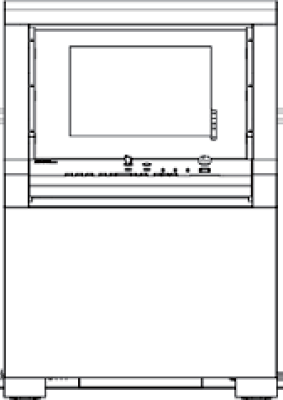
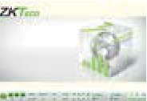
③

5 Check the scan image

① Put a baggage on the belt at the entrance and use the mouse to click on the "Forward" direction key to move the belt forward.
② After the baggage is conveyed to the shelf via the belt, the scanned image will appear on the screen in real-time. You can use image processing function to change image mode.
③ Use the mouse to click on the "Stop" button to stop the belt and take out the baggage from the shelf.


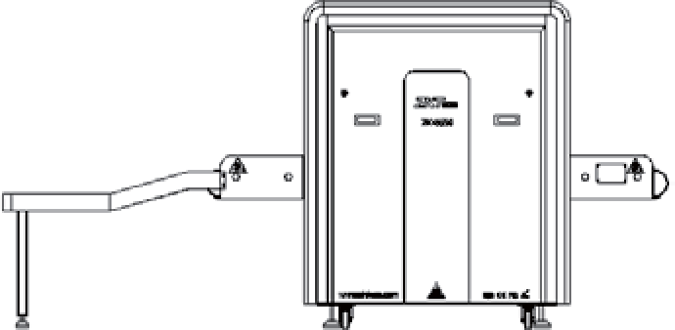

①

Put a baggage on belt and move it


②
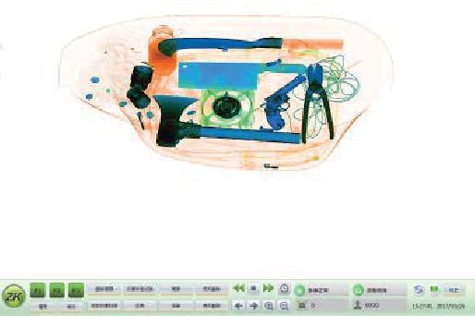
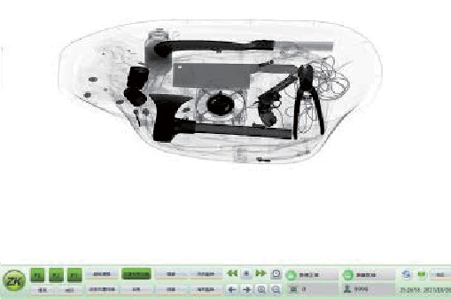

6 Power Oﬀ
① Reverse the key switch from "ON" to "OFF", when switching oﬀ the equipment.
Note: Do not unplug the power cable of the device until it is completely shut down.
② The screen will prompt "Shutdown" message followed by "Windows will shut down within one minute.” The device is completely turned oﬀ when the green work indicator is oﬀ.
③ The power cable can be disconnected after the equipment is completely turned oﬀ. Please take out the key and keep it at a safe place.



①
②
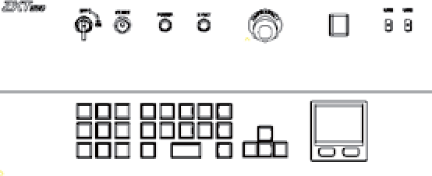

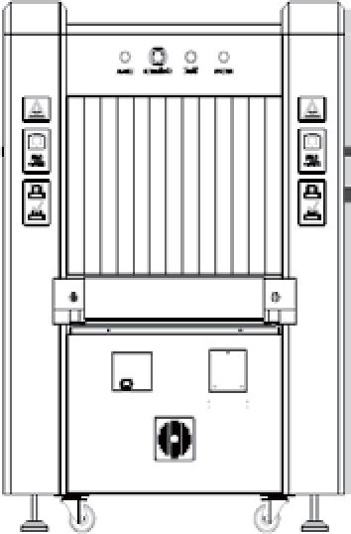

③
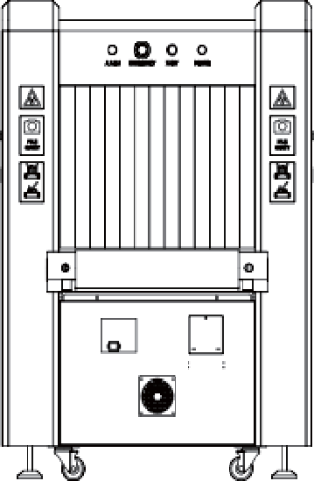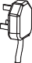



© Copyright 2018. ZKTeco Inc. ZKTeco Logo is a registered trademark of ZKTeco or a related company. All other product and company names mentioned are used for identiﬁcation purposes only and may be the trademarks of their respective owners. All speciﬁcations are subject to change without notice. All rights reserved.

