
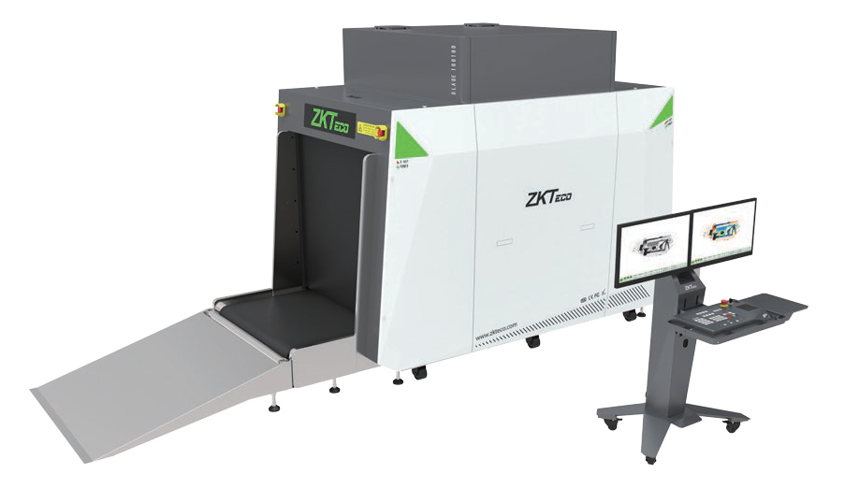

BLADE100100
X-ray Baggage Inspection System

BLADE100100 is an X-ray baggage inspection system with a tunnel size of 1010*1010(mm) which provides an effective inspection on big baggage and other items. It helps to identify suspicious items such as weapons, liquids, knives, fire guns, bombs, toxic substances, substances, ammunition and other dangerous objects which may lead to potential safety hazard by atomic number identification.
High image quality in combination with automatic identification of suspicious objects allows the operator to quickly and effectively evaluate any luggage content.

Features
- Real-time detection to aid operators in identifying suspicious item
- Typical steel penetration up to 35mm
- Uninterruptible Power Supply (UPS)
- Equipped with foldable rack

- Adjustable conveyor Speed
- Real-time Remote Monitoring System
- Luggage image and Walk Through Metal Detector status display on the same screen
- Threat Image Projection (TIP)
- Operator desk with two monitors

Options

- Video Surveillance • Gray Paint


( GL Exclusive Feature)

Technical Characteristics:
295
Tunnel Dimensions(W*H): 1010mm*1010mm Conveyor Speed: 0.20 m/sec ~ 0.40m/sec Load on Conveyer:
Max 200 kg (evenly distributed) Space Definition: HorizontalΦ1.0mm VerticalΦ2.0mm
Steel Penetration: 35mm (guaranteed);
38mm (typical) Wire Resolution: 38AWG (guaranteed);
40AWG (typical) Dual-energy Detector: Yes Number of Colors in X-ray Image: 3 Dimensions(L*W*H): 3200mm*1482mm*1917mm
Dimensions of Operator Desk (L*W*H): 797mm*789mm*1140mm
Package Dimensions (L*W*H): 2900mm*1500mm*2100mm
Weight: 1260kg + 70kg (Operator Desk) Package Weight: 1530kg
Film Safety: ASA/ISO1600 standard of film safety Single Inspection Dosage Rate: ≤1.0µGy

Dimensions (mm)
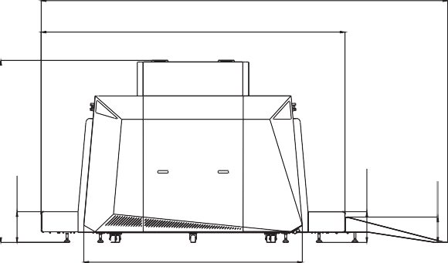
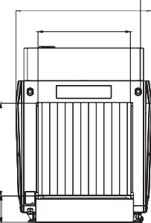
4282
3200
2301
1482
1010
1917
324
324
266
1010

Operating Environment:
Operating Temperature: -10°C to +45°C Storage Temperature: -20°C to +60°C Humidity: 5-95%, non condensing
Power Supply:230 VAC +/- 10% / 60/50 Hz (EU) 110 VAC +/- 10% / 60/50 Hz (US)
Power Consumption: Approx.1.0kVA Sound Pressure: <55.8dB (A)

X-ray Generator:
Tube Current: 0.5-1.2 mA (adjustable) Anode Voltage: 150-170 kV (adjustable) Generator Cool: Seal oil cooling / 100%

Computer Speci cation:
Processor: I7-7700 Monitor: 21” LED color Memory: 8 GB DDR4
Hard Drive: 240GB SSD+1TB HDD
Graphic Card: NVIDIA GeForce GTX 1660 Ti USB Port: 4 ports

Software Features:
Perfect View (PV) Black / White (B/W) Pseudo Colors (PS) Inverse View (IN) High Penetration (HP)
Real-time Image Processing Image Zoom(64x)
Image of Previous Baggage Programmable Function Keys Baggage Counter
Date / Time Indicator
Threat Image Projection (TIP) AI Intelligent Analysis
Platform software：ZKBio SIS
Status Monitoring of Walk Through Metal Detector

ZKTECO CO.,LTD.
www.zkteco.com
E-mail: sales@zkteco.com


Copyright © 2023 ZKTECO CO., LTD. All rights reserved. V2.0 2023.10.23

