ZKX6040A
Single Energy X-ray Inspection System

ZKX6040A is a single-energy X-ray screening system that provides a highly economical visual inspection solution for carry-on luggage.
clear scanning image, which allows operators to identify potential threat items visually.


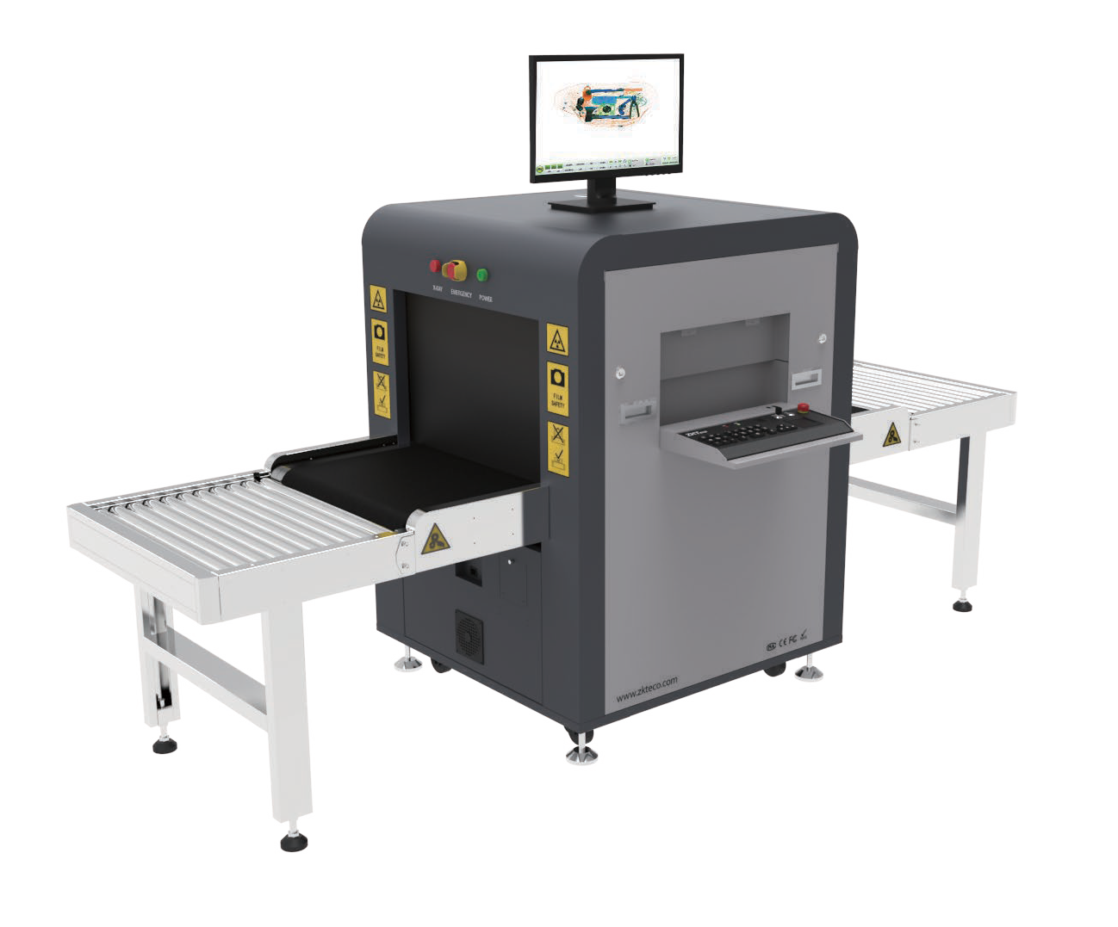
Features

Pseudo-color scanning image Bi-directional
Foldable Keyboard
Input/Output Roller Conveyor Energy Saving Mode

Options
Operator Desk Hard Disk
Video Surveillance
Display of Cluttered Bag Images together with the Status of the Walk-though Metal Detector

Software Features
Perfect View (PV) Black / White (B/W) Pseudo Colors (PS) Inverse View (IN) High Penetration (HP)
Real-time Image Processing and Image Zoom (64x) Image of Previous Baggage
Programmable Function Keys Baggage Counter
Date / Time Indicator
Threat Image Projection (TIP)

Speci cations

Technical Characteristics

Tunnel Dimensions (W*H) 600*400 (mm)
Conveyor Speed 0.3m/sec
Load on Conveyer 180kg (evenly distributed)
Conveyor Height 680 mm
HorizontalΦ1.0mm VerticalΦ2.0mm

Steel Penetration 8mm Wire Resolution 34AWG Single-energy Yes

Number of Colors in X-ray Image 3
Dimensions (L*W*H) 1701*910*1305 (mm) Dimensions with Packing(L*W*H) 2070*1150*1400 (mm) Net Weight 380 kg
Weight with Packing 480 kg
Film Safety
ASA/ISO1600 standard

Single Inspection Dosage Rate ≤1.0µGy
Supported Software ZKBio SIS
Communication Interface RJ45(TCP/IP)
Radiation Leak Dosage 0.25µ Gy/h (5cm from the surface)

Dimensions (mm)

Operating Environment

Operating Temperature -10°C to +45°C
Storage Temperature -20°C to +60°C
Humidity 5-95%, non-condensing
230 VAC +/- 10% / 60/50 Hz (EU)
Power Supply
110 VAC +/- 10% / 60/50 Hz (US)
Power Consumption Max. 0.3kVA
Sound Pressure 54dB

Computer Speci cations

Processor Inter core i3-4100 Monitor 21.5” LED display Memory Onboard 4 GB RAM
Rom 128G

USB Port 4 ports

Max. Storage Up to 10,000 scanned images

X-ray Generator

Tube Current 0.6 mA
Anode Voltage 80kV rated

Generator Cool Seal oil cooling / 100%

Orientation Vertically upwards

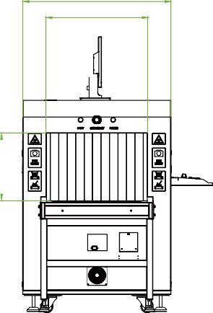
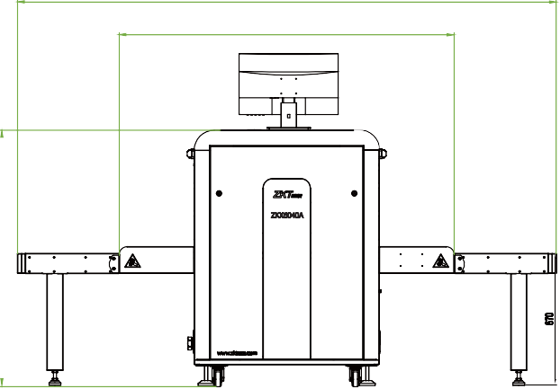
2736
910
600
1701
400


V6.1 10/24/2023
1305

ZKTECO CO.,LTD. www.zkteco.com E-mail: sales@zkteco.com Copyright © 2023 ZKTECO CO., LTD. All rights reserved.

